
INDUSTRY REPORT
Manufacturing in the US
Mar 2026

About

IBISWorld
IBISWorld specializes in industry research with coverage on thousands of global industries. Our comprehensive data and in-depth analysis help businesses of all types gain quick and actionable insights on industries around the world. Busy professionals can spend less time researching and preparing for meetings, and more time focused on making strategic business decisions.

Table Of Contents | Standard

1. About 4
Codes 4
Definition 4
Related Terms 4
What's Included 4
Related Industries 5
Additional Resources 5
2. At a Glance 6
Key Takeaways 6
Products and Services 8
Major Players 9
Key External Drivers 10
Industry Structure 10
SWOT 11
Executive Summary 11
3. Performance 13
Highlights 13
Key Takeaways 13
Performance Snapshot 14
Outlook 24
Life Cycle 28
4. Products and Markets 29
Key Takeaways 29
Products and Services 30
Major Markets 35
International Trade 38
Imports 41
Exports 43
5. Geographic Breakdown 45
Key Takeaways 45
Business Locations 46
6. Competitive Forces 52
Key Takeaways 52
Concentration 52
Barriers to Entry 53
Substitutes 54
Buyer & Supplier Power 56
7. Companies 58
8. External Environment 59
Key Takeaways 59
External Drivers 59
Regulation & Policy 62
Assistance 64
9. Financial Benchmarks 66
Key Takeaways 66
Cost Structure 66
Key Ratios 70
10. Key Statistics 72
Industry Data 72

1. About
https://my.ibisworld.com/us/en/industry/31-33/about

Codes
NAICS 2017 - USA | 31-33
NAICS 2022 - USA | 31-33

Definition
The Manufacturing sector includes operators engaged in the transformation of raw inputs into new products using mechanical, physical or chemical processes. Additionally, assemblage of component parts into new, complex goods is included in this sector, except where they should be considered construction (IBISWorld report 23). Goods may be sold directly to end users or to wholesalers for redistribution. Harvesting, extraction, resale and publishing are also not included in this sector.

Related Terms

OFFSHORING
The process of basing some or all of a company's resources abroad to take advantage of favorable operating costs and expand profit.

ECONOMIES OF SCALE
Cost savings enjoyed by larger operators with additional production volumes. Can be attained using factors such as bargaining power with suppliers.

INVENTORY MANAGEMENT
Planning and maintenance of inventory levels, balancing demand and inventory control costs.

What's Included
- Food, beverage and tobacco manufacturing
- Petroleum, coal and chemical manufacturing
- Transportation equipment and machinery manufacturing
- Metal and mineral production
- Computer and electronics manufacturing
- Wood and paper product manufacturing
- Other

Related Industries

Industries in the Same Sector
- Competitors:
  - No data available
- Complementors:
  - No data available

International Industries
- Synthetic & Natural Textile Manufacturing in Australia
- Household Textile & Soft Furnishing Manufacturing in the UK
- Wood Furniture Manufacturing in China

Additional Resources
- US Census Bureau
- US International Trade Commission
- US Bureau of Labor Statistics
- National Association of Manufacturers

2. At a Glance
https://my.ibisworld.com/us/en/industry/31-33/at-a-glance
Revenue  $7.3tr  ’21-’26 ↑ 0.2 %  ’26-’31 ↑ 0.5 % | Employees  12m  ’21-’26 ↓ 0.0 %  ’26-’31 ↑ 0.4 % | Businesses  621k  ’21-’26 ↑ 0.4 %  ’26-’31 ↑ 0.5 %
Profit  $503.7bn  ’21-’26 ↑ 1.4 % | Profit Margin  6.9%  ’21-’26 ↑ 0.4 pp | Wages  $862.7bn  ’21-’26 ↓ 0.0 %  ’26-’31 ↑ 0.4 %

Key Takeaways

Performance
- Manufacturing revenue has slowly grown over the past five years. However, high purchase fees have impacted profit, dampening growth. Despite these challenges, the sector has kept its head above water with modest gains.
- Revenue in the manufacturing sector will edge upward over the next five years. Continued demand from key markets and shifts in production methods will contribute to this growth. However, profit will remain under pressure from operational costs and other financial obligations.
- The US manufacturing sector faces broad cost and logistics risks when disruptions around major oil transit routes push up energy and freight prices, with particularly strong effects on energy-intensive industries. Companies are likely to respond through efficiency investments, supply chain diversification and careful pricing and production management.

Products and Markets
- China's tariff on US imports will severely hinder the competitiveness of key American exports, including semiconductors, aviation equipment and agricultural machinery. These higher costs will likely price US goods out of the Chinese market, reducing demand and cutting into revenue for major exporters like Boeing and Intel.
- Increased tariffs will increase input costs for industries reliant on Chinese materials, such as transportation equipment and fabricated metals, while curbing export opportunities. This dual pressure could lead to production slowdowns, profit margin declines and workforce reductions, particularly in states heavily tied to manufacturing supply chains like Michigan and Ohio.
- The manufacturing sector diversifies its output across various sectors. Essential products include food, beverages, tobacco, petroleum, coal, chemicals, transportation equipment and machinery. Other significant products include metal, mineral production, computers, electronics, wood and paper.
- Wholesalers represent the largest market for manufactured goods. Retailers, other manufacturers and the construction sector are also significant consumers. The diverse customer base helps stabilize the manufacturing sector even when specific markets suffer downturns.

Products and Services
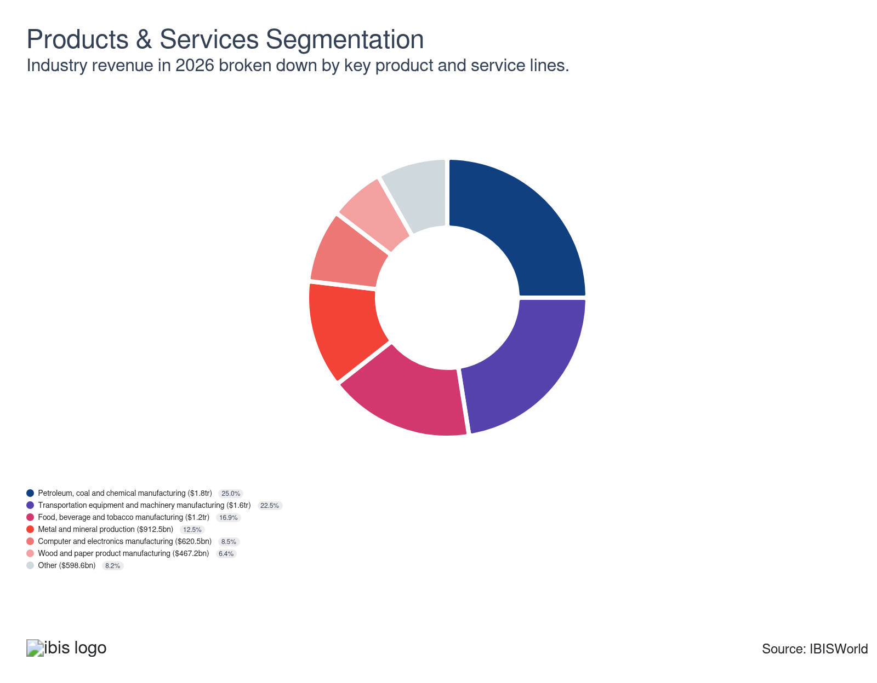

Major Players


Key External Drivers
Key External Drivers | Impact
Manufacturing capacity utilization | Positive
Industrial production index | Positive
World price of crude oil | Positive
Trade-weighted index | Negative
World price of steel | Positive

Industry Structure
Characteristic | Level | Trend
Concentration | Low
Barriers To Entry | Moderate | Increasing
Regulation and Policy | High | Increasing
Life Cycle | Mature
Revenue Volatility | Moderate
Assistance | High | Steady
Competition | Moderate | Increasing
Innovation | High

SWOT
Strengths  Low Customer Class Concentration  Low Product/Service Concentration  High Revenue per Employee | Weaknesses  Low Profit vs. Sector Average  High Capital Requirements | Opportunities  High Revenue Growth (2020-2025)  High Revenue Growth (2025-2030)  High Performance Drivers  Industrial production index | Threats  Low Revenue Growth (2005-2025)  Low Outlier Growth  Manufacturing capacity utilization

Executive Summary

Assembly required: An increase in the overall economy and a decline in the value of the US dollar will support sector revenue growth
The US manufacturing sector has achieved revenue growth over the past five years, benefiting from strong demand across industries such as automotive, electronics and consumer goods. Advances in production automation, including robotics and automated assembly lines, have reduced labor costs and errors, while 3D printing allows for rapid prototyping and tailored products. Lean manufacturing has minimized waste and improved quality, helping the sector maintain positive revenue even amid regulatory and commodity price pressures. Efficient global supply chains and impactful trade agreements, such as the USMCA, have sustained this growth, alongside innovations in predictive maintenance and data-driven operational optimization.
Despite overall growth, profit margin growth has been challenged by rising material and energy costs, particularly from surges in crude oil prices and tariffs on steel and aluminum. Manufacturers have countered these pressures by embracing energy-efficient technologies and substituting advanced materials, such as composites, to lower costs. Supply chain analytics optimizes forecasting and inventory management, while automation and just-in-time strategies minimize excess costs and improve efficiency. Sustainability efforts, including recycling and circular-economy practices, align cost savings with regulatory compliance. Cloud-based ERP systems have further enhanced planning and resource allocation, supporting financial performance. Revenue has been inching upward at a CAGR of 0.2% over the past five years and is expected to total $7,300.2 billion in 2026, when revenue will fall by an estimated 1.4%.
Looking ahead, manufacturing revenue is expected to grow moderately, driven by innovation and digital transformation. The growing adoption of artificial intelligence, IoT devices and machine learning will optimize production and quality control. Automation and robotics will increase efficiency and adapt to expanding consumer needs, while digitalization and smart factories will boost productivity using real-time data. Augmented reality tools will enhance training and maintenance. However, profit growth will be constrained by volatile material costs and increasingly stringent environmental regulations. Market agility will become essential as downstream markets and global trade continue to influence the sector’s strategic direction. Revenue is expected to increase at a CAGR of 0.5% to $7,495.5 billion over the five years to 2031.

3. Performance
https://my.ibisworld.com/us/en/industry/31-33/performance

Highlights
Revenue  $7.3tr  2021-26 CAGR ↑ 0.2 %  2026-31 CAGR ↑ 0.5 % | Employees  12m  2021-26 CAGR ↓ 0.0 %  2026-31 CAGR ↑ 0.4 % | Businesses  621k  2021-26 CAGR ↑ 0.4 %  2026-31 CAGR ↑ 0.5 %
Profit  $503.7bn  2021-26 CAGR ↑ 1.4 % | Profit Margin  6.9%  2021-26 CAGR ↑ 0.4 pp

Key Takeaways
- Manufacturing revenue has slowly grown over the past five years. However, high purchase fees have impacted profit, dampening growth. Despite these challenges, the sector has kept its head above water with modest gains.
- Revenue in the manufacturing sector will edge upward over the next five years. Continued demand from key markets and shifts in production methods will contribute to this growth. However, profit will remain under pressure from operational costs and other financial obligations.
- The US manufacturing sector faces broad cost and logistics risks when disruptions around major oil transit routes push up energy and freight prices, with particularly strong effects on energy-intensive industries. Companies are likely to respond through efficiency investments, supply chain diversification and careful pricing and production management.

Performance Snapshot
Revenue: | ↑ 2021-26 Revenue CAGR +0.2%
Revenue  $7.3tr  ’21-’26 ↑ 0.2 %  ’26-’31 ↑ 0.5 % | 2026 Revenue Growth  ↓ 1.4 % | Revenue Volatility  Moderate
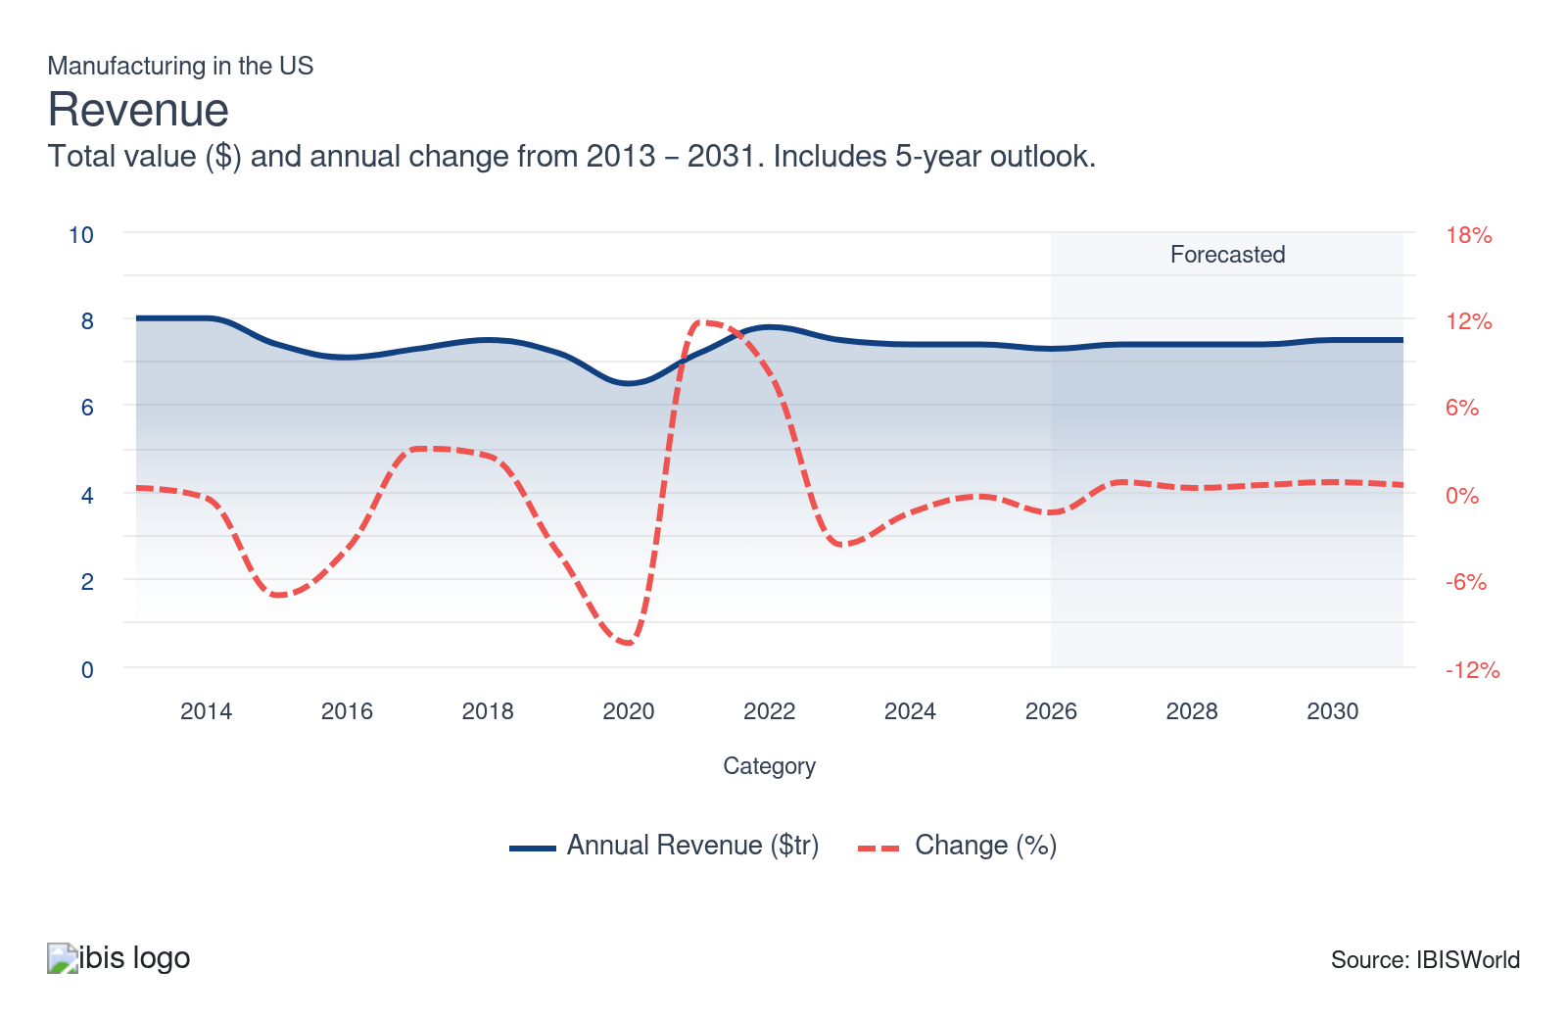
Employees: | ↓ 2021-26 Employees CAGR 0.0%
Employees  12m  ’21-’26 ↓ 0.0 %  ’26-’31 ↑ 0.4 % | Employees per Business  19  ’21-’26 ↓ 0.4 %  ’26-’31 ↓ 0.1 % | Revenue per Employee  $631k  ’21-’26 ↑ 0.2 %  ’26-’31 ↑ 0.1 %
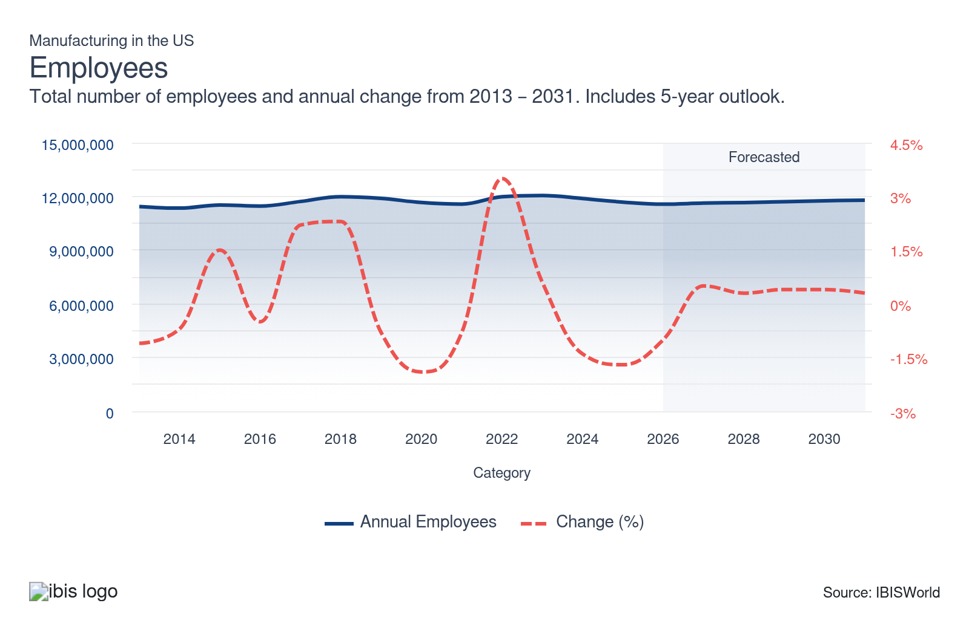
Businesses: | ↑ 2021-26 Business CAGR +0.4%
Businesses  621k  ’21-’26 ↑ 0.4 %  ’26-’31 ↑ 0.5 % | Employees per Business  19  ’21-’26 ↓ 0.4 %  ’26-’31 ↓ 0.1 % | Revenue per Business  $11.8m  ’21-’26 ↓ 0.2 %  ’26-’31 ↑ 0.0 %
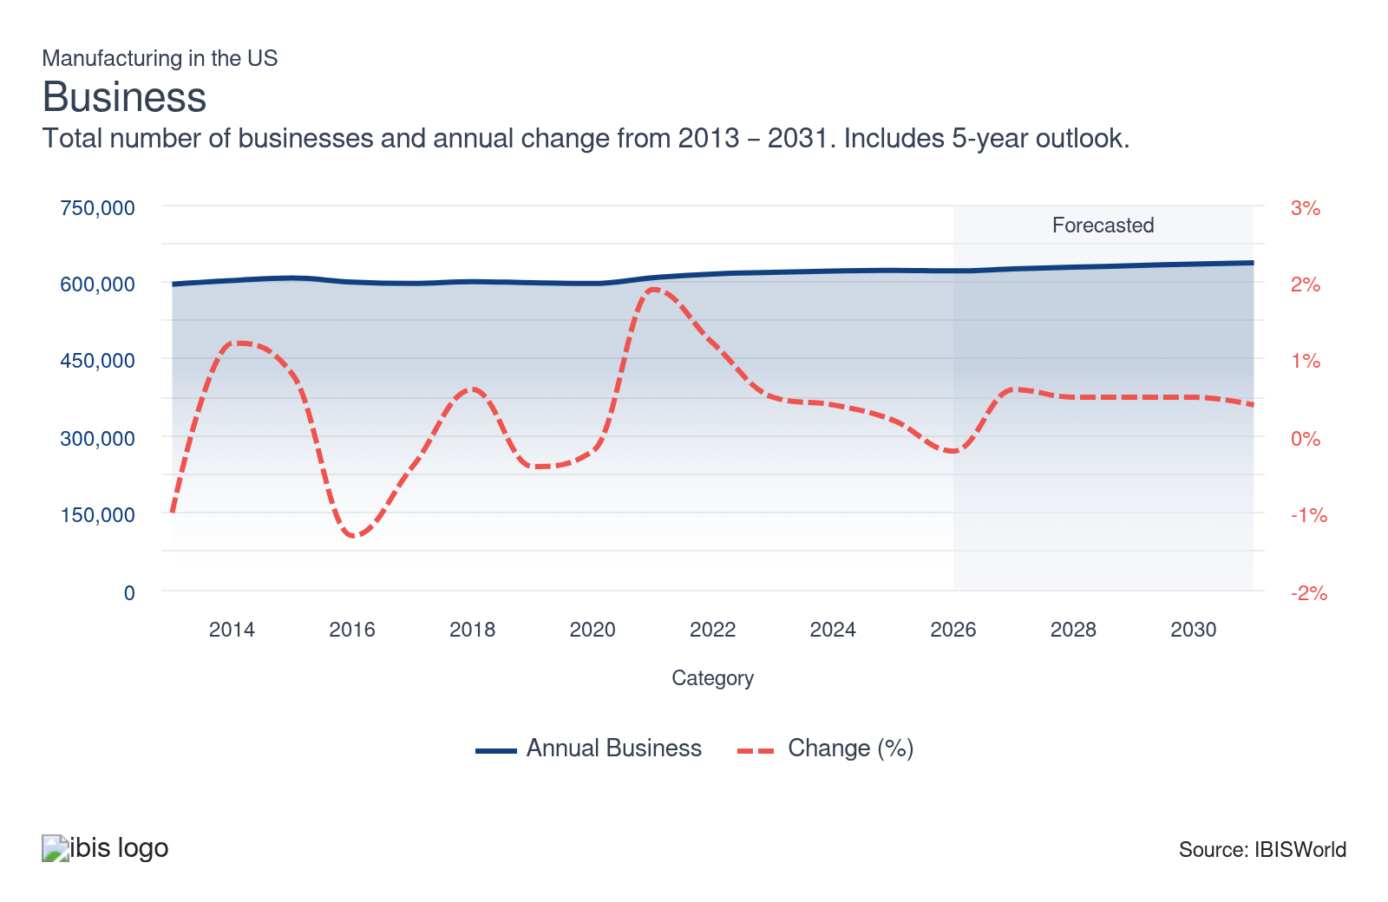
Profit: | ↑ 2021-26 Profit CAGR +1.4%
Total Profit  $503.7bn  ’21-’26 ↑ 1.4 % | Profit Margin  6.9%  ’21-’26 ↑ 0.4 pp | Profit per Business  $811.1k
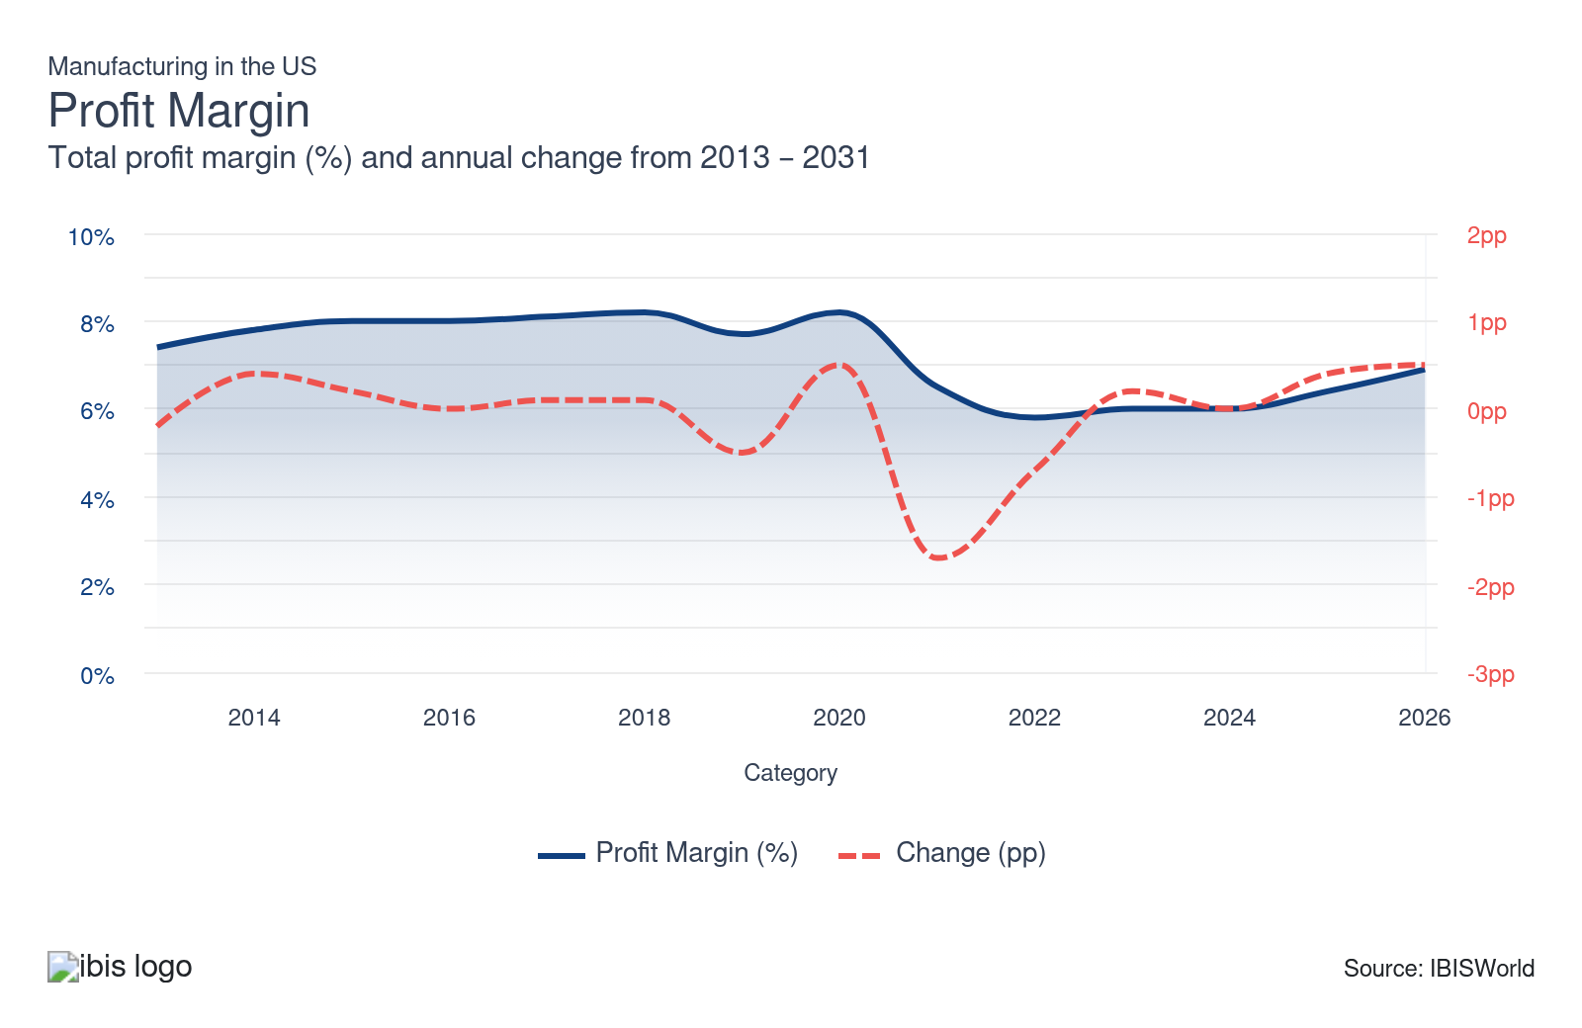
Current Performance
Current Performance

What's driving current industry performance?

Federal incentives catalyzed record-breaking private investment across advanced manufacturing sectors
- In response to the CHIPS and IRA acts passed in August 2022, US manufacturers announced over $395 billion in private investment and 115,000 new jobs by 2025, according to the White House. This unprecedented funding surge has significantly amended industrial strategy, making domestic production of semiconductors, EVs and clean technologies more viable and competitive than at any point in the past decade.
- According to the White House, CHIPS-related projects accounted for the majority of semiconductor investment, with companies like Intel and TSMC committing over $100 billion each by late 2024. These megaprojects have cemented the US as a global contender in advanced electronics manufacturing, reversing a decades-long decline in domestic chip fabrication capabilities and reducing reliance on East Asian supply chains.
- The 48C Advanced Manufacturing Tax Credit program, reinstated under the IRA, awarded its full $10 billion allocation by January 2025 across 240+ projects. This accelerated deployment of clean-tech components such as battery cells, heat pumps and grid equipment illustrates how fiscal policy has become a central lever for guiding manufacturing direction and technology adoption.
- By early 2025, 57 EV and battery projects were operational, with over 100 under construction, representing $197.6 billion in capital commitments. According to the Environmental Defense Fund, the scale and speed of deployment illustrate how federal incentives transformed investor behavior, pushing forward entire supply chains and regional economies in Georgia, Michigan, North Carolina and Tennessee.

Reshoring surged as firms moved production back to the US to mitigate global risks
- In 2024, approximately 244,000 US manufacturing jobs were announced because of reshoring and foreign direct investment (FDI), according to the Reshoring Initiative. Although slightly below the 2023 peak, this continues a significant trend driven by firms’ desire to increase resilience amid geopolitical uncertainty and reduce overreliance on China and Southeast Asia.
- Cumulative reshoring and FDI-related job announcements since 2010 surpassed 2.5 million by 2025. This long-term pivot reflects a fundamental re-evaluation of total cost of ownership, where domestic stability, automation potential and proximity to end markets increasingly outweigh marginal labor cost savings abroad.
- According to Reuters, foreign chipmakers such as TSMC and Samsung alone invested $102.6 billion in US semiconductor facilities between late 2024 and early 2025. Their decisions validate US industrial policy but also raise strategic dependencies, such as local talent shortages and infrastructure bottlenecks.
- Many reshoring decisions were also shaped by supply chain shocks during the pandemic, which highlighted weaknesses in global just-in-time models. As a result, manufacturers increasingly favor “China+1” or “US-first” sourcing models to ensure continuity, improve lead times and regain control over logistics and inventory.

Labor market tightness intensified operational pressure despite near-full employment recovery
- According to the Bureau of Labor Statistics, US manufacturing employment reached nearly 12.6 million as of January 2026, returning to pre-pandemic levels. However, the rebound has not eased chronic labor shortages, which remain a top constraint for firms scaling production in capital-intensive, skilled-trades environments.
- Manufacturing job openings were 415,000 in May 2025, signaling continued hiring strain. According to NAM's Q2 2025 survey, 48.0% of manufacturers cited talent availability as their primary concern, limiting output expansion despite strong demand and new facility construction, particularly in advanced and clean manufacturing sectors.
- In 2023, total compensation for manufacturing workers averaged $102,629, reflecting both inflation and competitive wage pressures. This elevated compensation structure has improved job attractiveness but also increased firms' cost structures, compelling them to invest more heavily in automation and lean process optimization.
- Training initiatives have expanded in response, but the pace remains uneven. Many regions lack sufficient technical education pipelines aligned with modern manufacturing needs, exacerbating mismatches between job requirements and labor supply, especially in semiconductor fabrication, robotics maintenance and battery production.

Energy efficiency and carbon intensity became priority metrics amid federal decarbonization push
- US manufacturing accounts for roughly 30.0% of national GHG emissions, making decarbonization a top priority. According to the EPA, over 100 US plants were ENERGY STAR certified in 2023 for top-quartile energy efficiency, demonstrating early success in embedding sustainability into factory operations.
- The Department of Energy launched a $6 billion Industrial Decarbonization program in March 2023, supporting pilot projects for green steel, low-carbon concrete and hydrogen-powered facilities. This program signaled a long-term policy shift: emissions reduction is no longer just environmental, it’s becoming an industrial competitiveness strategy.
- According to the American Chemistry Council, member companies reduced GHG intensity by more than 8.0% from 2017 to 2022. These gains reflect investment in clean electricity and carbon capture and processing innovations, which are now crucial for firms securing procurement contracts from climate-conscious buyers and government agencies.
- The federal "Buy Clean" initiative, introduced in 2023, began reforming procurement standards for steel, cement and glass, favoring low-carbon US producers. This change is critical for domestic manufacturers seeking to differentiate on environmental performance and win government infrastructure and defense contracts.

Steel mill products volatility creates ongoing uncertainty for US manufacturers’ cost planning
- Producer Price Index (PPI) growth for steel mill products saw dramatic volatility throughout 2020-2025, with a plunge of 9.6% in 2020, a surge of 90.2% in 2021, followed by 8.7% growth in 2022, then declines of 16.2% in 2023, 10.5% in 2024 and 15.9% in 2025. The five-year CAGR settled at 5.5%, reflecting recent headwinds after sharp price inflation.
- Manufacturers across the US experienced pronounced cost volatility throughout this period, requiring frequent reevaluation of material budgets and contracting approaches. Following the extreme escalation in 2021, manufacturers faced margin compression if cost pass-through agreements with customers lagged behind rapid PPI swings. Liquidity management was a critical concern for many producers as input purchase prices fluctuated.
- With steel integral to automotive, machinery, construction and appliance production, PPI swings disrupted project timing and inventory prioritization. Distributors and wholesalers serving these manufacturers faced inventory risk as they bought steel at peak prices, only to see selling prices decline in 2023-2025. Price declines in 2024 and 2025, at 10.5% and 15.9% respectively, alleviated headline expenses but also introduced risks related to inventory writedowns and cash flow management.
- Given these unpredictable price moves, manufacturers and their suppliers focused on diversifying sourcing arrangements and locking in prices via contracts where possible. Strategic inventory decisions shifted toward just-in-time practices to avoid losses from holding high-cost steel through downturns. Long-term contracting and vertical integration became more attractive for those seeking to counter future price shocks.

Cold rolled steel sheet and strip price swings force manufacturers to retool procurement and pricing strategies
- Cold rolled steel sheet and strip, critical for automotive, appliance and fabricated metals manufacturers, saw the PPI surge 153.2% in 2021, then tumble 6.4% in 2022, slump 25.6% in 2023, decrease 2.7% in 2024 and plunge 20.4% in 2025, resulting in a five-year CAGR of 6.4%. These dramatic moves created both windfalls and threats for different stakeholders.
- For manufacturers, cost spikes in 2021 forced rapid renegotiation of supplier contracts and triggered price increases for downstream buyers. Inventory managers who purchased at peak levels faced substantial writedowns as prices fell sharply from 2023 through 2025. Squeezed profit led to tightened spending elsewhere, prompting some firms to delay capital projects or enter new hedging arrangements.
- Distributors and wholesalers were similarly challenged by the need to manage inventory risk and maintain pricing consistency with customers. The 2024 and 2025 declines, at 2.7% and 20.4%, abruptly reversed the prior cost inflation, introducing opportunities for those able to time purchases but penalizing those holding high-priced stock. These trends enhanced the priority of flexible procurement systems and shorter-term price-setting mechanisms.
- Manufacturers increasingly leveraged data analytics to anticipate PPI direction and improve purchasing decisions. A focus on operational efficiency and on value engineering to reduce steel use also gained traction as a long-term response to structural price volatility. The extent and suddenness of changes during this period emphasized the absolute need for dynamic supply chain management.

The Iran conflict raises broad energy and freight costs for US manufacturers
- In March 2026, the conflict between the United States and Iran heightened concern over oil and gas flows through the Strait of Hormuz, which in 2024 carried roughly one-fifth of global petroleum liquids consumption and more than one-quarter of global seaborne oil trade, according to the US Energy Information Administration. This raised the prospect of higher and more volatile energy costs.
- Higher, more volatile energy prices associated with disruptions at key shipping chokepoints can raise operating costs across US manufacturing industries. Sectors with high fuel or electricity intensity, such as metals, chemicals and transportation equipment, may feel these effects more strongly. Increased freight and insurance costs can also impact domestic and export logistics, potentially lengthening delivery times.
- Manufacturers may respond by revisiting pricing, sourcing and production planning decisions to manage cost pressures and uncertainty. Some firms could accelerate investments in energy efficiency, automation and process optimization to mitigate higher utility bills. Others may reassess the balance between domestic and international suppliers based on changing freight economics and reliability considerations.
- Over the medium term, persistent geopolitical and logistics risk could influence capital allocation, favoring locations and configurations that provide more resilient access to energy and transport infrastructure. Supply chain diversification, including nearshoring or multi-sourcing strategies, may become more prominent in corporate planning. These shifts could gradually reshape the structure of US manufacturing supply networks.

What influences industry volatility?

Revenue volatility is heightened by exposure to cyclical demand swings and input cost pressures
- Revenue swings often originate from capital goods order cycles and construction activity fluctuations. Investment slowdowns across end-user segments such as automotive and construction equipment manufacturers contribute to abrupt demand contraction. In addition, supply-side disturbances, including steel and semiconductor shortages, amplify revenue instability as manufacturers face uncertain production schedules and working capital challenges.
- Changes in US trade policy and persistent global supply chain disruptions further accentuate revenue volatility. Tariffs on metals and retaliatory duties on finished goods have at times distorted procurement patterns and forced manufacturers to reconfigure sourcing strategies abruptly. Exposure to such macro and regulatory shifts necessitates agile inventory and capacity management, as well as ongoing reassessment of supplier relationships to buffer against unpredictable margin pressures.

Product portfolio breadth mitigates risk while narrow specialization increases vulnerability to demand shocks
- Diversification across product categories and target end-markets provides manufacturers with greater revenue stability. For example, chemical manufacturers supplying both automotive and consumer packaging demonstrate lower revenue variability during sector downturns in one end-market. Conversely, manufacturers tied exclusively to heavy machinery or aerospace remain exposed to deep cyclical contractions linked to capital expenditure deferrals or delayed aircraft orders, intensifying overall business risk.
- Moving toward value-added categories, such as medical device components or specialized packaging solutions, further reduces demand cyclicality by anchoring revenue to regulated or recurring-purchase markets. Manufacturers with such diversified portfolios demonstrate superior operational resilience and competitive positioning, attracting investors seeking lower risk premiums and more predictable cash flows.
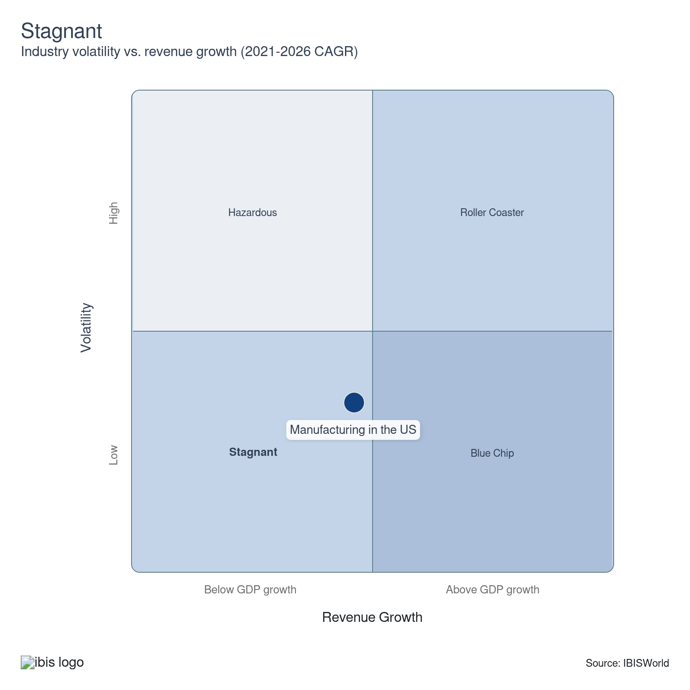

How do successful businesses overcome volatility?
Incorporate long-term sales contracts
Securing agreements that guarantee sales volume for extended periods provides needed revenue stability and protects against market swings. These contracts allow manufacturers to plan production and manage cashflow more predictably.
Leverage economies of scope
Producing multiple related products efficiently from shared operations creates flexibility to shift focus as market demand changes. The ability to adapt output quickly cushions the effects of downturns in any single product category.
Outlook | ↑ 2026-31 Revenue CAGR +0.5%

What's driving the industry outlook?

US clean energy and EV manufacturing capacity is expected to expand dramatically over the outlook period
- According to the Environmental Defense Fund (EDF), the US is projected to produce 4.7 million electric vehicles annually by 2028. This expansion, driven by federal EV sales targets and IRA tax credits, is catalyzing rapid growth in auto and battery manufacturing while reshaping supplier networks in states like Michigan, Georgia and Nevada.
- Domestic battery production capacity is projected to reach 1,083 GWh by 2028, enough to power over 12 million EVs per year. This shift will reduce reliance on Asian battery imports, build energy security and support a new wave of lithium processing, recycling and critical mineral manufacturing across the US.
- According to the DOE, advanced battery and EV manufacturing will benefit from Section 45X production credits through 2032, helping maintain cost parity with international competitors. These credits lower the effective cost of production, enabling US-based plants to scale more competitively and attract long-term capital.
- Industry dynamics are shifting to vertically integrated models, with automakers partnering directly with battery suppliers and raw material producers. These joint ventures aim to lock in capacity, control cost volatility and meet domestic content rules required for federal incentives, transforming traditional OEM-supplier relationships.

Advanced semiconductor manufacturing will redefine the US tech-industrial base
- TSMC’s Arizona fab is expected to reach full production in 2025, with a second facility online by 2028. According to IEEE Spectrum, these plants will produce 4-nm and 3-nm chips, restoring US access to cutting-edge process nodes and reducing geopolitical risk in global electronics and defense supply chains.
- The CHIPS Act aims to raise the US global market share of leading-edge semiconductor production from near zero in 2021 to 30.0% by 2032. If achieved, this target would represent a foundational realignment in US competitiveness, especially as AI, autonomous systems and defense platforms demand high-performance chips.
- Intel’s multi-state fab expansion, supported by a $7.86 billion CHIPS Act award in November 2024, is expected to create over 10,000 permanent jobs. This scale of impact emphasizes how semiconductor policy is acting as an economic development engine for entire regional ecosystems.
- Equipment and material suppliers are also scaling US operations to serve next-gen fabs. This second-order effect is vital, as the success of CHIPS Act implementation depends not only on flagship projects but also on the formation of complete domestic semiconductor supply chains, including EDA tools, photomasks and packaging.

Industrial automation and robotics adoption will accelerate to offset long-term labor constraints
- The International Federation of Robotics (IFR) forecasts that global robot installations will grow by ~4.0% annually through 2027, with the US capturing a rising share. As labor gaps persist and production complexity increases, US manufacturers will expand automation investments to stabilize output and mitigate risks tied to staffing volatility and wage inflation.
- Generative AI, real-time analytics and predictive maintenance systems will become widespread in smart factories. These tools will allow for lower defect rates, faster changeovers and real-time quality control, making digital transformation a key competitive lever, especially in high-mix, low-volume production settings.
- The integration of collaborative robots (cobots) will become increasingly important in mixed-skill environments. These robots enable flexible automation in tasks like assembly and inspection without requiring complete factory redesign, making them attractive for small and mid-sized manufacturers struggling with talent shortages.
- According to BLS projections, the total number of manufacturing jobs will decline slightly through 2032, but this masks tens of thousands of annual job openings because of turnover. Automation will be crucial for maintaining output levels as manufacturers face a retirement wave and slow workforce replenishment.

Industrial decarbonization will scale from pilot projects to commercially viable operations
- DOE-funded pilot programs launched in 2023 to decarbonize steel, cement and chemical production are expected to yield deployable results by 2027-2028. These initiatives will offer blueprints for commercially scaling low-emission processes, which are increasingly necessary to meet investor ESG goals and regulatory baselines.
- As of 2026, dozens of projects are using CCUS, green hydrogen and electrified heat to reduce industrial emissions. By 2030, a growing subset of these technologies is expected to reach commercial viability, shifting cost curves and altering procurement preferences across sectors such as construction and heavy manufacturing.
- Federal procurement standards through Buy Clean and Infrastructure Law provisions will increasingly favor low-carbon domestic goods, creating a guaranteed market for early adopters. This market certainty reduces investment risk, particularly for firms committing to retrofit older facilities or building new net-zero-capable plants.
- The US will also likely adopt more stringent emissions reporting standards by 2028-2029, aligning with global frameworks such as the EU’s CBAM and SEC climate disclosure rules. Manufacturers that fail to modernize could face barriers in international trade or lose access to institutional capital focused on climate-aligned portfolios.

US manufacturing faces cost pressures and supply risks as tariffs ramp up
- As of March 2026, US manufacturers are contending with a new 10.0% global minimum tariff on most imports, combined with higher country-specific “reciprocal” rates on major trading partners such as China, the EU, Japan and South Korea, which together are driving up costs for raw materials, machinery and intermediate inputs. These blanket and reciprocal increases pose challenges for firms heavily reliant on global supply chains, potentially raising production expenses for everything from industrial equipment to finished consumer goods.
- Tariffs on primary materials are compounding these pressures. Steel and aluminum imports remain subject to expanded Section 232 tariffs, generally at 25.0% and, in some cases, up to 50.0% for specific products or source countries, increasing the cost of essential components for manufacturers in industries such as automotive, electronics and machinery. These elevated costs could erode margin competitiveness and lead to higher finished product prices for downstream buyers and consumers in the US.
- Reciprocal tariffs are a major source of ongoing uncertainty. Domestic manufacturers now face higher “reciprocal” tariffs on imports from key partners such as Japan, South Korea and various emerging markets, with rates in many cases moving into the mid-teens to mid-20s or higher, depending on the partner and product. If these countries retaliate with their own duties on US exports, opportunities for American manufacturers in overseas markets could constrict further, harming producers with international customers.
- Global retaliation has shaped manufacturers’ export outlooks. In April 2025, China sharply raised retaliatory tariffs on many US imports, with additional duties on some products climbing into the mid-double to low-triple digits before a temporary 90-day truce was agreed in May 2025. Under that deal, both sides briefly reduced their additional tariff burdens, with China cutting some retaliatory tariffs on US goods from around 125.0% back toward a residual 10.0% level and the US partially suspending its latest reciprocal increases on Chinese imports. While this eased immediate pressure, uncertainty persists as further negotiations loom and the temporary reductions could be reversed if talks stall.
- Chinese retaliatory tariffs on US goods have at times reached very high levels, with peak rates reported in the mid-double to low-triple digits on some products during the 2025 escalation, even though subsequent temporary agreements have lowered effective rates on selected lines.

Steel wire price contraction offers relief to US manufacturers but heightens pressure on producers
- Steel wire, widely used in construction, automotive and a variety of components, is projected to contract further, with the Product Price Index (PPI) estimated to drop 2.6% in 2026, decrease 3.0% in 2027, fall 1.5% in 2028, remain flat in 2029 and decline 2.9% in 2030, leading to a five-year CAGR decline of 2.0%. The persistent downward trend signals lower input costs for industries relying on these products.
- US manufacturers and OEMs can expect reduced material expenses, helping to rebuild profit eroded during earlier periods of inflation. Lower steel wire prices will improve domestic competitiveness and potentially strengthen export positioning for finished goods. Cost predictability will facilitate longer-term contracts and pricing certainty with their own customers.
- In contrast, wire producers face narrowing profit as selling prices trend downward, especially if raw material slack persists. Manufacturing overcapacity and subdued construction demand, combined with global oversupply, are likely contributors to these declines. This environment will intensify pressure on producers to optimize operational efficiency and pursue consolidation or differentiation strategies.
- Distributors and wholesalers may benefit from enhanced purchasing leverage, but will need to monitor for supply chain contraction risks if lower prices prompt producer exits or production cuts. Strategic partnerships with stable, high-quality producers may become increasingly valuable as stakeholders seek to balance cost savings with consistent availability.

Cold rolled steel sheet and strip PPI projected to further decline, stabilizing input cost management for manufacturers
- Price contraction for cold-rolled steel sheet and strip is expected to continue, with the PPI forecast to decrease 3.1% in 2026, dip 0.7% in 2027, edge up 0.2% in 2028, slide 1.1% in 2029 and fall 4.3% in 2030. The five-year CAGR is projected to decrease 1.8%, offering stability after a period of heightened volatility.
- Manufacturers across the automotive, appliance and fabrication industries will likely gain from lower and more predictable input costs, enabling improved profit planning and potentially more aggressive competitive pricing. Contract negotiation terms will shift, with buyers demanding better price-lock agreements and tolerating less supplier quote volatility.
- For cold-rolled sheet producers, these trends portend profit pressures and challenge manufacturing sustainability, incentivizing process improvements and potentially reducing US production capacity. Firms unable to realize cost reductions may see consolidation or reallocation of output toward more specialized or value-added products. Regulatory changes on waste reduction and energy use will further impact cost competitiveness.
- Distributors and wholesalers will be afforded a more advantageous position to time purchases and reduce inventory expense, but must remain alert to any supply chain shakiness if domestic producers exit. The period ahead prioritizes lean inventory strategies and close monitoring of international market trends affecting supply and input cost dynamics.
Life Cycle | Mature

Why is the industry mature?

Contribution to GDP
Contribution to GDP reflects foundational economic interdependence as US manufacturing anchors critical supply chains, supports employment and provides intermediate goods for sectors such as construction, automotive and defense. This output underpins broad economic resilience, prompting capital allocation toward process modernization and workforce development to maintain strategic relevance within national economic priorities.

Market Saturation
Market saturation remains high across most US manufacturing sub-industries because of a longstanding domestic presence, established distribution networks and entrenched customer relationships. Limited untapped demand magnifies the importance of differentiated product offerings and efficiency improvements, leading manufacturers to prioritize market share gains and operational refinements over capacity-driven expansion for margin preservation.

Innovation
Incremental innovation dominates, typified by ongoing improvements in advanced composites for aerospace manufacturing or precision additive manufacturing in medical devices. However, relatively few truly disruptive shifts have emerged outside segments like electric vehicle battery production, pressuring capital allocation toward internal R&D and targeted partnerships that support faster product cycle refreshes and defend pricing power.

Consolidation
Consolidation has accelerated, driven by cost pressures, technological investments and global competition. High-profile M&A activity, such as the acquisition of automation solutions providers by diversified manufacturers, reflects a drive to achieve operational synergies, extend product portfolios and strengthen bargaining positions with buyers and suppliers. This consolidative trend strengthens incumbents while narrowing entry routes for smaller entities.

Technology and Systems
Technology and systems adoption, notably digital manufacturing, industrial IoT and robotics, are transforming US manufacturing by raising throughput, improving quality and reducing labor intensity. For example, the rollout of fully automated assembly lines in automotive manufacturing has reset productivity benchmarks, compelling re-alignment of capital spending, workforce reskilling and supplier integration strategies to secure sustained cost advantages and product differentiation.

4. Products and Markets
https://my.ibisworld.com/us/en/industry/31-33/products-and-markets
Largest Market  $1.8tr  Petroleum, coal and chemical manufacturing | Product Innovation  High

Key Takeaways
- China's tariff on US imports will severely hinder the competitiveness of key American exports, including semiconductors, aviation equipment and agricultural machinery. These higher costs will likely price US goods out of the Chinese market, reducing demand and cutting into revenue for major exporters like Boeing and Intel.
- Increased tariffs will increase input costs for industries reliant on Chinese materials, such as transportation equipment and fabricated metals, while curbing export opportunities. This dual pressure could lead to production slowdowns, profit margin declines and workforce reductions, particularly in states heavily tied to manufacturing supply chains like Michigan and Ohio.
- The manufacturing sector diversifies its output across various sectors. Essential products include food, beverages, tobacco, petroleum, coal, chemicals, transportation equipment and machinery. Other significant products include metal, mineral production, computers, electronics, wood and paper.
- Wholesalers represent the largest market for manufactured goods. Retailers, other manufacturers and the construction sector are also significant consumers. The diverse customer base helps stabilize the manufacturing sector even when specific markets suffer downturns.

Products and Services
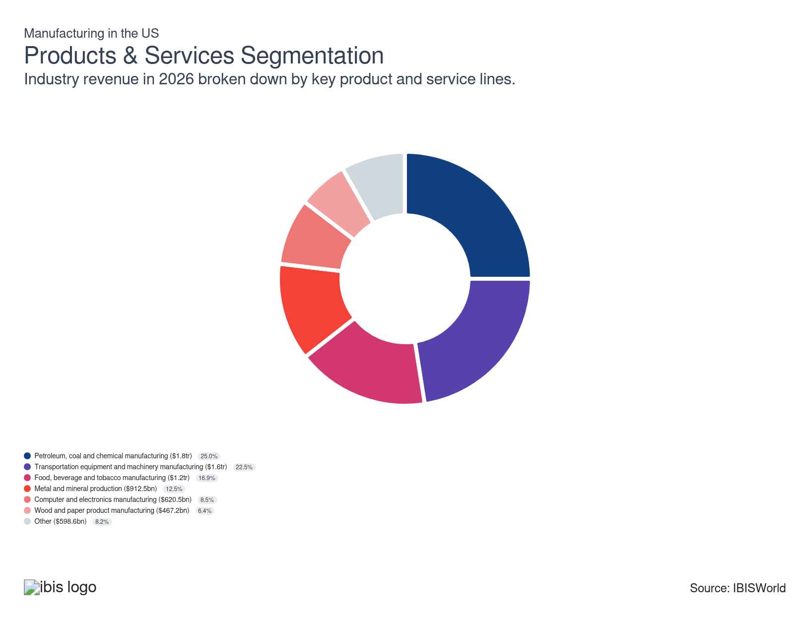

How are the industry’s products and services performing?

Petroleum, coal and chemical manufacturing adapts to regulatory pressures and downstream specialization
- US chemical manufacturers serve automotive, construction and agriculture supply chains, delivering products such as polyethylene resins, fertilizers and specialty coatings. The segment accounts for the largest revenue share, although its share has slightly decreased over the past five years as decarbonization initiatives limit fossil-derived feedstock use and new environmental review standards delay facility expansion. Demand remains strongest in industries investing in lightweight polymers or energy transformation.
- Differentiators include proprietary process technologies, integrated cracker-refinery complexes and compliance with Toxic Substances Control Act revisions. Profit margin holds for specialty chemicals such as photoinitiators for LEDs, buoyed by demand from electric vehicle factories and architectural glass manufacturers. Strategic innovation, such as investment in bio-based intermediates and waste-to-chemicals conversion, has allowed leading manufacturers to reposition portfolios and sustain return on invested capital despite rising input volatility.

Transportation equipment and machinery manufacturing responds to technology migration and re-shoring
- Products in this segment include passenger vehicles, commercial trucks, aircraft engine components and industrial robotics. They are collectively driven by US infrastructure investment and export demand for high-durability assets. Revenue share has grown incrementally, reflecting federal incentives for domestically assembled electric vehicles and supply chain relocation trends. Core demand derives from logistics operators, airlines, defense procurement and large-scale agriculture operators modernizing fleets or production lines.
- Manufacturers achieve differentiation through advanced materials, automation, proprietary drivetrain or avionics systems and regulatory certification, such as Federal Aviation Administration Parts Manufacturer Approval. Electric vehicle drivetrain and battery module innovation has significantly improved competitive positioning against imported combustion-engine assemblies. Investment in joint ventures for battery manufacturing and collaboration on autonomous systems continues to raise barriers to entry and stabilize segment profitability on a multi-year basis.

Food, beverage and tobacco manufacturing has adapted supply chains and processing capabilities
- Product differentiation in this category is characterized by highly automated facilities, strict compliance with Food Safety Modernization Act protocols and branded value chains targeting health-conscious and convenience-oriented consumers. This offering’s revenue contribution has remained stable, as rising demand for ready-to-eat meals and premium beverages counterbalances gradual declines in certain processed foods. Key end-market drivers include expanding retail private label programs and restaurant supply partnerships.
- Plant-based protein product innovation and premiumization trends, such as aseptic packaging for shelf-stable beverages, have enhanced product margin and defensibility against traditional imported alternatives. Commodity cost fluctuations remain a risk, but manufacturers deploying advanced analytics in procurement demonstrate improved resilience. Producers evolving towards functional food lines and traceable ingredient sourcing capture higher-margin business, prompting ongoing capital expenditure in process upgrades and digital tracking.

Metal and mineral production aligns with domestic policy and advanced manufacturing trends
- This segment produces steel beams, aluminum extrusions and copper wiring, supplying construction, automotive and electrical grid end-users. Revenue contribution has been steady, with upward shifts tied to infrastructure stimulus and strategic mineral sourcing initiatives under the Defense Production Act. Policy-driven tariffs and Buy America requirements have redirected procurement toward domestic producers, compressing substitution from foreign-sourced intermediate goods.
- Key differentiators include mastery of electric arc furnace technology, access to recycling feedstocks and adherence to Occupational Safety and Health Administration standards for workplace exposure. Profitability has been sustained for niche offerings such as high-manganese pipeline steel used in liquefied natural gas transport, outpacing commodity-grade flat steel because of specialized performance and regulatory compliance requirements. Investments in near-net shape casting and closed-loop recycling systems have improved cost structure and appeal to environmentally driven procurement mandates.

Computer and electronics manufacturing sharpens competitive margin through miniaturization and supply chain digitalization
- Producers in this category deliver microprocessors, network hardware and imaging devices. Specialized semiconductor and printed circuit board output serves US defense, telecommunications and high-value medical equipment manufacturers. The share of sector revenue has grown slowly, driven by domestic incentives under the CHIPS and Science Act and steady downstream demand. Key end-markets prioritize reliability and compliance with International Traffic in Arms Regulations.
- Product differentiation emerges from patent-backed chip architectures, software-hardware integration and investment in advanced logic node fabrication. US manufacturers hold a margin advantage in field-programmable gate arrays and sensor arrays optimized for aerospace applications. Strategic realignment through licensing agreements and vertical integration of assembly-test-packaging operations supports resilience against offshore component risk, enabling more predictable gross margin in a shifting geopolitical environment.

Wood and paper product manufacturing sustains profitability via sustainable sourcing and process innovation
- This segment supplies engineered lumber, corrugated packaging and tissue. The revenue proportion has gradually declined, affected by digital substitution in printing and slow residential construction starts. Packaging and hygiene paper products remain the largest US output by value, with demand strongest in e-commerce and institutional cleaning supply channels. Forestry stewardship certification and lightweight package design have emerged as market entry standards.
- Differentiation centers on chain-of-custody documentation, mill automation and rapid design-cycle ability for custom packaging. Corrugated box manufacturers leveraging digital printing and fast-turnaround design-to-delivery cycles outperform traditional bulk producers on both profit and customer retention. Innovations in recycling de-inked pulp and energy recovery from mill waste have enabled these manufacturers to manage rising input costs and retain margin on premium product lines.

Other manufacturing capitalizes on customized production and responsive supply chain services
- The remaining segment includes textiles, plastics, printing and furniture manufacturing. Revenue share has remained stable, with spikes in customized medical devices and promotional display hardware offsetting declines in traditional textiles. End-markets emphasize flexibility, short-run production and domestic supply assurance, particularly for defense and emergency response supply chains.
- Customization capability, rapid prototyping and integration with just-in-time delivery networks enable higher value realization compared to standardized imports. Plastics producers investing in advanced 3D printing for aerospace and medical uses have secured long-term supply contracts, enhancing segment stability. Sustained profit depends on continual process improvement and logistics alignment with domestic distributors and retailers.

What are innovations in industry products and services?

Additive manufacturing enables complex component design and disrupts traditional supply chains
- Additive manufacturing, exemplified by metal 3D printing for turbine blades, introduces a disruptive shift in production methods by allowing the direct creation of complex geometries unachievable with older fabrication techniques. US manufacturers with defense and aerospace exposure have been the earliest adopters. Penetration remains limited among mid-tier and small-scale contract manufacturers because of high capital requirements for industrial-grade printers and qualified materials.
- This technology reconfigures both supply chain strategies and product development cycles. Reduced tooling needs and shortened lead times enable rapid prototyping and facilitate custom, low-volume production capabilities that were previously cost-prohibitive. For manufacturers, commercial viability hinges on vertical integration of design and engineering teams, establishing process certification standards and maintaining intellectual property barriers, strengthening their ability to command higher-margin, value-added segments in complex machinery and critical components.

Industrial IoT platforms drive predictive maintenance and incremental productivity improvements
- Industrial IoT platforms embedded in equipment, including automotive assembly robots with condition-monitoring sensors, represent an incremental innovation. Sensors are being gradually integrated across large-scale US manufacturing campuses, with higher adoption rates in automotive, electronics and advanced packaging. Uptake in clusters like food processing is slower, constrained by fragmented equipment bases, lack of interoperability and cybersecurity concerns.
- The innovation creates tangible commercial impacts through data-driven predictive maintenance, reducing unplanned downtime, optimizing asset utilization and refining throughput forecasting. For manufacturers, enhanced asset visibility enables more accurate cost modeling and targeted capital allocation. Competitive advantage derives from the ability to synchronize operations across distributed facilities, raising productivity benchmarks and supporting just-in-time supply models, reinforcing leading positions in efficiency-centric manufacturing verticals.

Servitization accelerates, opening recurring revenue streams via advanced aftersales contracts
- Transitioning from simple product sales to bundled offerings, such as heavy equipment manufacturers providing real-time telematics-based maintenance programs, marks an incremental innovation with accelerating adoption among US capital goods manufacturers. Barriers to full penetration include significant investment in digital infrastructure, evolving salesforce capabilities and restructuring legacy pricing models.
- Servitization creates new commercial opportunities through recurring service contracts, long-term relationships and customer lock-in, lowering sensitivity to economic cycles. This model enables differentiation beyond core mechanical features and justifies price premiums, thereby reshuffling competitive positions to favor manufacturers with robust digital capabilities and established service networks. Specifically, those able to leverage remote diagnostics and data analytics cultivate stronger client retention and steady cash flows, increasing intrinsic enterprise value.

What products or services do successful businesses offer?
Manufacture highly innovative products
Constantly bringing novel products to market attracts early adopters and sustains brand excitement. Successful innovation keeps a manufacturer ahead of competitors while commanding premium pricing and loyalty.
Provide superior after-sales service
Exceptional support after purchase reassures customers and differentiates a manufacturer from those offering less comprehensive service. Strong after-sales relationships encourage repeat business and can generate positive referrals within the sector.

Major Markets


What’s influencing demand from the industry’s markets?

Wholesalers consistently act as the primary revenue source due to scale and supply chain integration
- Wholesalers account for the largest share of the sector’s revenue, reflecting high-volume purchasing and stable demand for standardized goods. Demand sophistication is moderate; wholesalers focus on bulk procurement efficiency, reliable lead times and regulatory conformity for broad product classes such as electrical components or fasteners. This market's revenue share has remained stable in the past five years, due mostly to concentrated distribution relationships and widespread use of contractual supply agreements.
- Wholesalers demonstrate moderate cyclical exposure since their purchasing mirrors downstream retail and industrial flows. Vertical integration efforts, typically via large wholesalers expanding into private label production, increase procurement pressure on manufacturers and can compress profit.
- Limited customization requirements insulate this segment, but growing end-user demand for traceability and supply resilience is pushing both wholesalers and manufacturers toward digitized inventory tracking. The high portion of industry reliance on wholesalers supports stable cash flows but increases exposure to inventory risk and negotiating power concentration.

Retailers’ pursuit of differentiated offerings drives shifting demand for higher-value manufactured products
- Retailers represent the second-largest market, characterized by strong consumer-driven demand that prioritizes product differentiation, rapid fulfillment and compliance with safety or labeling standards. Demand for sophistication is high in categories like consumer electronics, with a preference for exclusive features, sustainability claims, or rapid product lifecycle renewal. Over the past five years, revenue share from retailers has gradually increased as direct-to-consumer models and premium private label programs have gained traction alongside traditional retail channels.
- The market exhibits high cyclicality, with purchasing volumes adjusting quickly to shifts in consumer sentiment and macroeconomic shocks. Increasing vertical integration by retailers through exclusive sourcing agreements and branded manufacturing puts pressure on traditional manufacturers’ profit and innovation cycles. Heightened end-user focus on sustainable production and digital interfacing requires manufacturers to invest in compliance and product tracking.

Direct sales to manufacturers remain a stable, technically demanding revenue stream underpinned by quality and reliability requirements
- Sales to downstream manufacturers constitute a significant share, defined by high technical requirements, stringent quality assurance and consistent specification compliance in components such as precision-machined parts for automotive or aerospace producers. Demand for sophistication is very high, including mandated traceability and certifications such as ISO 9001 or AS9100. This market’s revenue share has remained stable, supported by supplier qualification processes and sustained capital investment in US manufacturing.
- Cyclical exposure is moderate; fluctuations in downstream production impact order volumes, but long-term contracts and inventory buffering reduce volatility. Vertical integration among downstream manufacturers (e.g., bringing production of key subsystems in-house) has increased, driving strategic partnerships or competitive displacement for suppliers. End-user demand for advanced materials and digital integration, such as sensor-enabled products, has grown, compelling adaptation among upstream manufacturers.

Construction-related demand remains cyclical yet essential for baseline manufacturing stability
- Purchases by construction companies, including those supplying fabricated steel, engineered wood, or HVAC assemblies, provide a steady baseline demand despite significant exposure to macroeconomic cycles. Demand sophistication is moderate, focusing on cost, availability and meeting building code standards. The construction market’s share of revenue has declined over the past five years, mainly because of volatility in non-residential investment and increased import competition for commodity materials.
- Highly cyclical purchasing patterns challenge manufacturers’ production planning and necessitate flexible supply contracts. Vertical integration among larger construction groups, encompassing both material procurement and prefabrication, pressures manufacturers to provide value-added services or risk margin erosion. Sustainability requirements, including LEED certification and low-emission products, are gaining prominence, creating differentiated opportunities for suppliers with compliant offerings.

Niche and specialty markets offer limited but high-value opportunities driven by tailored specifications
- The remaining market constitutes specialized buyers such as medical device fabricators or custom equipment assemblers, defined by low revenue share but exacting technical and compliance requirements. Demand for sophistication is extremely high; products may require unique certifications such as FDA clearance for medical-grade plastics or build-to-spec components for defense contractors. Revenue share has been stable, sustained by entrenched supplier relationships and high switching costs.
- Limited cyclicality is a feature in these sub-segments, as purchasing is driven by project-based or regulatory-tied needs rather than broad economic cycles. Vertical integration is minimal, but supplier concentration creates strategic partnership opportunities. Customized solutions for end-users seeking unique product features or regulatory compliance drive pricing premiums, but require deep technical knowledge and agile engineering. Low overall exposure to these markets reduces systemic risk but provides a platform for margin enhancement and intellectual property-driven differentiation.

International Trade
Total Imports  $2.9tr  ’21-’26 ↓ 0.1 %  ’26-’31 ↑ 0.4 % | Total Exports  $1.4tr  ’21-’26 ↑ 0.6 %  ’26-’31 ↑ 0.6 % | Trade Balance  Net Importer  ↓ Deficit: $-1.5tr

International Trade Imports
International Trade Imports
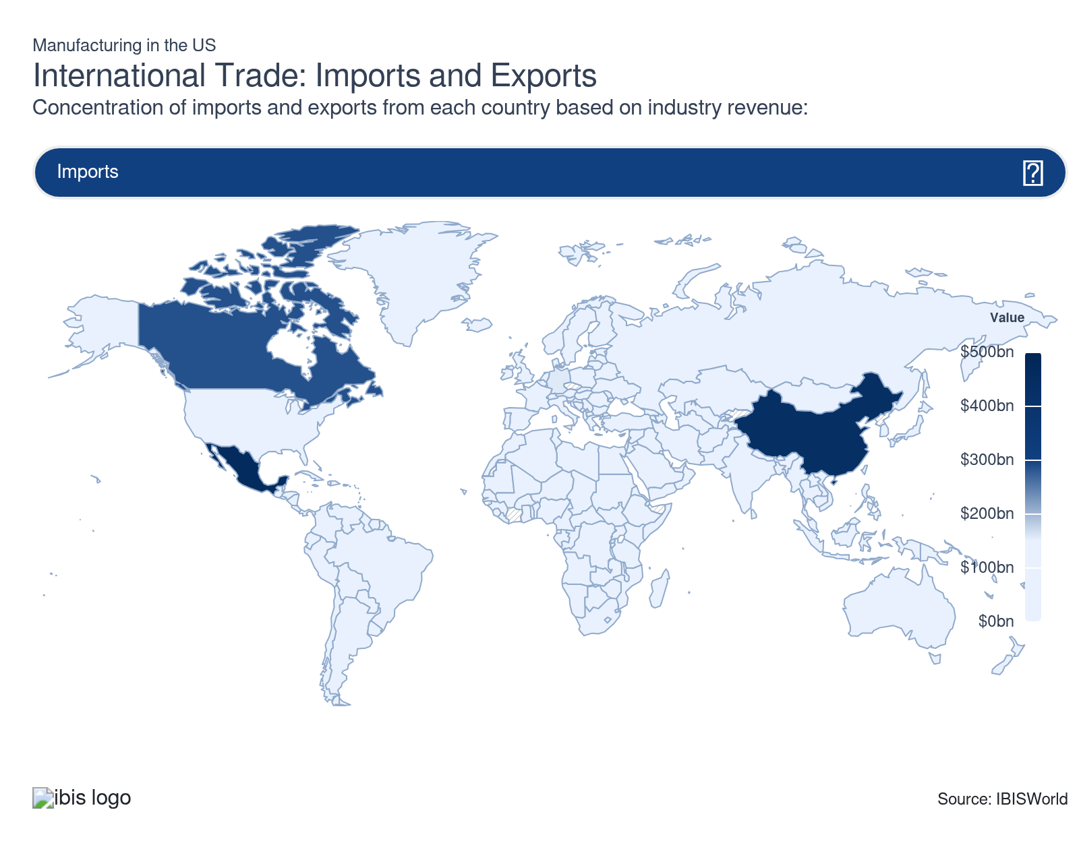
International Trade Exports
International Trade Exports
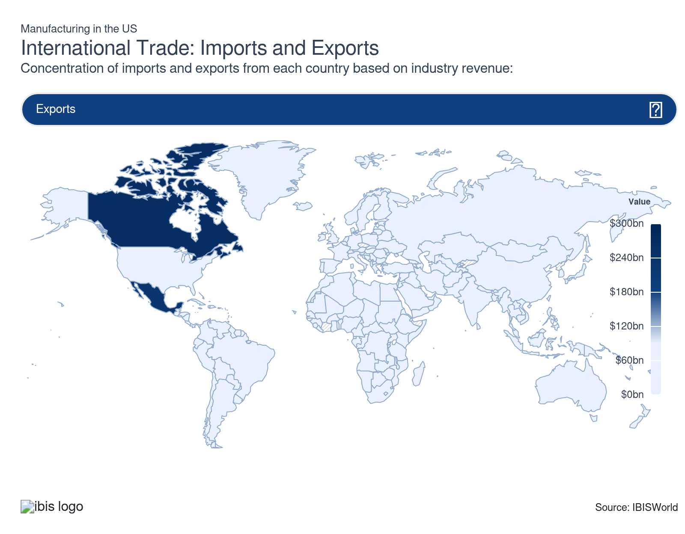

Imports
Moderate | Steady

What are the industry’s import trends?

Mexico’s rising export share has reinforced domestic production integration and moderated cost pressures
- Manufacturers in Mexico benefit from close geographic proximity to the US, streamlined supply chains and longstanding production integration. The country’s industrial base has been shaped by extensive maquiladora operations specialized in automotive components, consumer electronics and industrial machinery assembly. US-Mexico-Canada Agreement (USMCA) compliance requirements have driven investments in quality and traceability, directly supporting these manufacturers’ competitive positioning.
- Tariff-free access granted under the USMCA has stabilized cross-border trade, lowered transaction costs and removed uncertainty associated with short-term trade policy adjustments. Mexican exports generally meet rigorous US regulatory standards, facilitating broad import penetration. Import dependence has reduced exposure to currency volatility and logistics disruptions, supporting more predictable capacity utilization within the sector.
- Domestic manufacturers often position their products as higher-value alternatives to Mexican imports, leveraging perceptions of superior durability and after-sales support. Nonetheless, Mexican imports have increased their share of total sector imports over the past five years. This shift reflects competitive labor costs and integrated supply chain efficiencies, especially in complex assemblies. Domestic manufacturers must continuously optimize operational flexibility and reconfigure production networks to sustain pricing discipline and hedge against further share gains by Mexican imports.

China’s declining import share reflects cost pressures, shifting compliance risks and changing sourcing strategies
- Chinese manufacturing strength has centered on large-scale production of electrical equipment, fabricated metals and consumer goods. Competitive cost structures have historically driven high US import volumes, but increasingly stringent US tariffs and regulatory scrutiny have eroded Chinese manufacturers’ price advantage. Enforcement of Section 301 tariffs and heightened compliance checks have increased procurement complexity and extended lead times for US importers.
- The industrial base in China is marked by deep process specialization and integrated supply ecosystems, enabling cost-efficient high-volume manufacturing. However, recurring supply chain shocks and foreign exchange volatility have prompted many US manufacturers to diversify sourcing to mitigate operational risk. Perceptions of inconsistent quality and concerns over intellectual property enforcement have further influenced a shift in procurement strategy.
- A significant reduction in Chinese import share over the past five years has limited direct pricing pressure on domestic manufacturers and provided headroom to increase production volumes. Strategic allocation of production resources toward high-specification products, such as precision bearings and advanced control systems, has further differentiated the domestic offering. Continued transition toward regionalized supply networks will offer stable capacity utilization and improved resilience to global logistics disruptions for US-based producers.

Domestic manufacturers pursue advanced automation to strengthen competitive resilience against high imports
- Import penetration in the sector has remained strong over the past five years. Cheaper foreign production from Mexico and China, currency differentials and reduced supply-chain friction have exerted incremental upward pressure on import share, especially for cost-sensitive components and basic assemblies.
- US manufacturers have intensified investments in advanced automation and precision engineering to protect their share against this moderate import growth. Robotics adoption on production lines, proprietary process improvements and targeted upgrading of quality control allow domestic producers to compete more effectively, especially in high-tolerance segments like aerospace fasteners. Also, domestic manufacturers actively support lobbying for anti-dumping duties on product categories where imported goods benefit from price advantages tied to state subsidies.
- Continued modest import growth heightens exposure to global cost competition, raising the risk of margin compression for those reliant on commodity-grade output. However, this environment creates opportunities for domestic manufacturers to capture greater value through exclusive manufacturing partnerships, quick-turn custom runs, or by specializing in highly regulated end-uses such as medical device components. Pivoting resources toward defensible, specification-driven production confers more robust pricing power and market stability.

Exports
Moderate | Increasing

What are the industry’s export trends?

Canada’s stable production standards and regulatory alignment sustain consistent demand for US manufactured exports
- Canada’s manufacturing base relies on imported production components and industrial machinery to support advanced manufacturing and assembly operations, which incentivizes a steady flow of high-value US-manufactured exports. Alignment between US and Canadian regulatory frameworks, specifically in areas governed by the United States-Mexico-Canada Agreement, has facilitated efficient border clearance and predictable compliance for US suppliers. Canadian regulators’ established acceptance of US standards, especially for electrical equipment and automotive parts, reduces compliance costs for US manufacturers and minimizes approval delays, strengthening exporters’ competitive positioning.
- Domestic Canadian buyers recognize US products for reliability, technologically advanced features and compliance with emissions and safety requirements, particularly in machinery and fabricated metal components. This reputation continues to influence large-scale purchasing decisions among original equipment manufacturers and parts distributors in the automotive and aerospace industries. Greater price sensitivity has emerged in response to fluctuations in the US-Canada exchange rate, but procurement strategies generally sustain a preference for dependable imported inputs that meet performance thresholds.
- Canada consistently represents the largest single-country destination for US-manufactured exports. Its share of overall exports from the US has remained stable in the past five years because of persistent industrial integration and cross-border supply chains, especially in transport equipment and machinery.
- Limited shifts have been observed following USMCA's implementation, though tariff disputes on steel and aluminum have affected trade flows and inventory management costs. Strategic implications for US manufacturers include maintaining capacity flexibility and inventory buffers to accommodate sudden regulatory or currency-driven shifts in Canadian demand.

Mexico’s expanding manufacturing capacity and regulatory reforms drive increased US exports of industrial inputs
- Mexico’s industrial production environment is defined by a concentrated cluster of automotive assembly, electronics and consumer goods manufacturers, which anchor demand for US-manufactured exports such as engines, electrical components and production tooling. Regulatory changes over the past decade, particularly the harmonization of standards and the adoption of North American technical norms under USMCA, have reinforced value chain integration and lowered market entry barriers for US producers.
- Perceptions of US product quality in Mexican markets emphasize durability, technical support and compatibility with manufacturing lines. Industrial buyers in Mexico’s northern states have increasingly prioritized imported inputs that speed up assembly processes and reduce defect rates. This, combined with regulatory streamlining, accounts for an incremental but measurable shift in Mexico's share of US-manufactured exports over the past five years, with its share modestly rising as Mexican assembly operations scale up.
- Exported goods to Mexico are subject to currency fluctuations and shifting energy costs, which impact industry margins in both directions. Tariff reductions and the removal of non-tariff barriers under USMCA have generally improved pricing consistency and facilitated just-in-time shipment practices.
- As Mexico’s share of total sector exports increases, US manufacturers face growing strategic exposure to local labor policy changes and operational risks linked to border logistics. Investment-oriented manufacturers are advised to deepen local partnerships and diversify logistics channels to preserve supply chain resilience as Mexico’s role in US manufacturing trade intensifies.

Export volumes have remained stable while producers leverage North American trade ties for resilience
- Over the past five years, exports as a share of total sector revenue in the US have remained stable. Global supply chain disruptions, incremental shifts in international demand and persistent US dollar strength have contributed to this steadiness, with incremental variation generally offset by countervailing factors. Canada and Mexico together continue to absorb a substantial proportion of sector exports, reflecting the enduring advantage conferred by nearshoring relationships and regional trade frameworks.
- Manufacturers have reinforced established commercial networks in North America, prioritizing supply reliability and logistical efficiency, particularly under the USMCA provisions. Minimal adjustments have occurred in outbound product categories, with only selective adaptation for regulatory or technical compliance in markets such as China and the United Kingdom. Key exporters have remained focused on mature, high-volume lines, such as automotive components and heavy machinery, where US-based producers possess entrenched capabilities and established customer relationships.
- Stable export volumes heighten the sector’s exposure to geopolitical and trade risks in its major trading partners while offering a baseline for operational predictability. Opportunities exist for manufacturers able to deepen supply integration with Canadian and Mexican buyers through digitalized logistics or co-production ventures. However, concentration in a limited set of export markets could amplify vulnerability to future policy or macroeconomic shifts, reflecting the need for diversification strategies or new market development beyond the current focus.

5. Geographic Breakdown
https://my.ibisworld.com/us/en/industry/31-33/geographic-breakdown

Key Takeaways
- The Southeast region is a crucial hub with significant manufacturing activity driven by its favorable business environment and labor markets. Many companies have established operations here to take advantage of these conditions.
- The Great Lakes region, rich in industrial history, continues to be a manufacturing powerhouse, benefiting from its skilled labor pool and robust infrastructure. Companies in this area focus on diverse product lines, including transportation equipment and machinery.

Business Locations
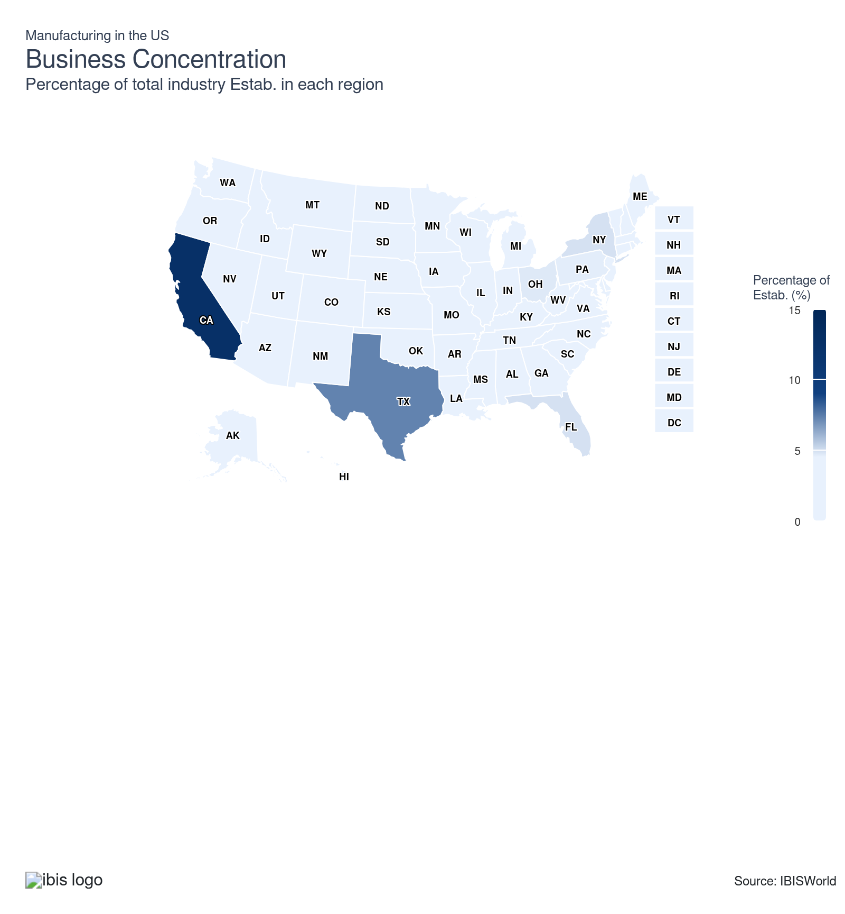
State | Estab.  Units | Estab.  % | Population  %
California | 35936 | 5.4 | 11.5
Texas | 20781 | 3.1 | 9.4
Florida | 13942 | 2.1 | 7.0
New York | 13931 | 2.1 | 5.8
Ohio | 13390 | 2.0 | 3.5
Pennsylvania | 13245 | 2.0 | 3.8
Illinois | 12530 | 1.9 | 3.7
Michigan | 12196 | 1.8 | 3.0
North Carolina | 8704 | 1.3 | 3.3
Wisconsin | 8505 | 1.3 | 1.7
Georgia | 7860 | 1.2 | 3.3
Indiana | 7964 | 1.2 | 2.0
New Jersey | 7075 | 1.1 | 2.8
Minnesota | 6800 | 1.0 | 1.7
Washington | 6745 | 1.0 | 2.3
Massachusetts | 6008 | 0.9 | 2.1
Tennessee | 5800 | 0.9 | 2.1
Missouri | 5490 | 0.8 | 1.8
Oregon | 5309 | 0.8 | 1.2
Colorado | 5105 | 0.8 | 1.8
Virginia | 4963 | 0.7 | 2.6
Arizona | 4456 | 0.7 | 2.2
South Carolina | 3990 | 0.6 | 1.6
Alabama | 4145 | 0.6 | 1.5
Connecticut | 3772 | 0.6 | 1.1
Kentucky | 3659 | 0.5 | 1.3
Utah | 3655 | 0.5 | 1.0
Iowa | 3418 | 0.5 | 0.9
Louisiana | 3050 | 0.5 | 1.3
Oklahoma | 3245 | 0.5 | 1.2
Maryland | 2859 | 0.4 | 1.8
Arkansas | 2529 | 0.4 | 0.9
Kansas | 2699 | 0.4 | 0.9
Idaho | 2102 | 0.3 | 0.6
Mississippi | 2019 | 0.3 | 0.9
Nevada | 2027 | 0.3 | 1.0
Maine | 1690 | 0.3 | 0.4
Nebraska | 1769 | 0.3 | 0.6
New Hampshire | 1755 | 0.3 | 0.4
Montana | 1415 | 0.2 | 0.3
New Mexico | 1311 | 0.2 | 0.6
Rhode Island | 1206 | 0.2 | 0.3
South Dakota | 1039 | 0.2 | 0.3
Vermont | 1020 | 0.2 | 0.2
West Virginia | 1075 | 0.2 | 0.5
Hawaii | 743 | 0.1 | 0.4
Alaska | 564 | 0.1 | 0.2
Delaware | 608 | 0.1 | 0.3
North Dakota | 691 | 0.1 | 0.2
Wyoming | 604 | 0.1 | 0.2
District of Columbia | 106 | 0.0 | 0.2

Where are industry businesses located?

Southeast region logistics and labor advantages reinforce competitive positioning for transportation equipment manufacturing
- A dense network of intermodal ports and rail corridors distinguishes the Southeast as a prime logistics hub. Manufacturers leverage integrated access to eastern seaports, air freight gateways and major highway arteries that connect production sites with downstream automotive and aerospace clients. This physical connectivity supports rapid material flows, underpins just-in-time inventory models and reduces landed costs for transportation equipment outputs moving toward assembly centers or export terminals.
- The region’s manufacturing ecosystem benefits from a longstanding tradition of technical education aligned with industry requirements. Vocational programs in states such as Alabama and South Carolina continuously supply maintenance engineers, robotics technicians and quality assurance specialists, all of whom are essential to transportation equipment manufacturing. High labor force participation in union and non-union plants sustains flexible staffing models that meet cyclical demand, supporting rapid operational scaling.
- Automotive parts, engines and aerospace components dominate the Southeast’s output portfolio, reflecting alignment with the nearby presence of original equipment manufacturers and tiered suppliers. Locational clustering of these outputs tightens supplier-producer integration, enabling manufacturers to accelerate new product introductions that match evolving specifications from automotive and aviation clients. This proximity reduces lead times while offering cost and reliability advantages over more distant manufacturing locations.

Great Lakes region specialization in steel and machinery manufacturing leverages infrastructure and location for supply chain stability
- Heavily industrialized, the Great Lakes region draws strength from a mature infrastructure network supporting steel and heavy machinery manufacturing. Access to navigable inland waterways and rail links provides a ready connection to both raw material inputs, such as iron ore and key end markets in vehicle assembly and construction equipment. Well-established interstate trucking corridors facilitate reliable movement between foundries, fabrication sites and distribution nodes in Chicago, Detroit and Cleveland.
- The region's concentration of metallurgical and engineering expertise bolsters its technical edge. Generations of investment in research labs and apprenticeship pipelines have created deep pools of skilled machinists, metallurgists and process engineers. The presence of trade schools and partnerships with regional universities sustains a steady stream of specialized workers, critical for maintaining precision standards in metals and machinery output.
- Blast furnaces, rolling mills and heavy machinery assembly lines predominate in the region, reflecting infrastructure suited to bulk processing and precision manufacturing. The clustering of these activities contributes to robust supplier networks, streamlined logistics of heavy and oversized commodities and minimized freight costs. Establishing production operations here confers resilience during raw material fluctuations and supports responsive delivery to automotive and equipment manufacturing clients in the Midwest.

West region’s concentration in electronics and high-specification food manufacturing advances market access and innovation potential
- The West’s significance to the sector rests on a dual foundation: a technology-driven electronics cluster and an advanced food processing ecosystem. Electronics manufacturers capitalize on proximity to West Coast innovation centers and supply chains associated with semiconductor fabrication. Universities in California and Arizona strengthen access to skilled electrical engineers, designers and technicians, supporting the development of microprocessors and advanced computing hardware.
- Food and beverage manufacturing growth is supported by local access to diverse agricultural inputs, cold-chain logistics and certification facilities. Producers of specialty health beverages and value-added ingredients benefit from streamlined compliance with environmental standards set by California’s regulatory framework. This environment encourages sustainable operations, which can serve as a market differentiator for producers targeting health-conscious consumers.
- West Coast ports, air cargo capacity and proximity to Asian export markets give the region distinct transportation advantages. Manufacturers of computer hardware and foodstuffs achieve shorter shipping cycles and faster market entry, supporting premium pricing strategies and reducing exposure to global freight volatility. Establishing operations in this region enables tighter integration of research, product development and delivery, enhancing competitiveness and ensuring supply chain continuity for high-value product categories.
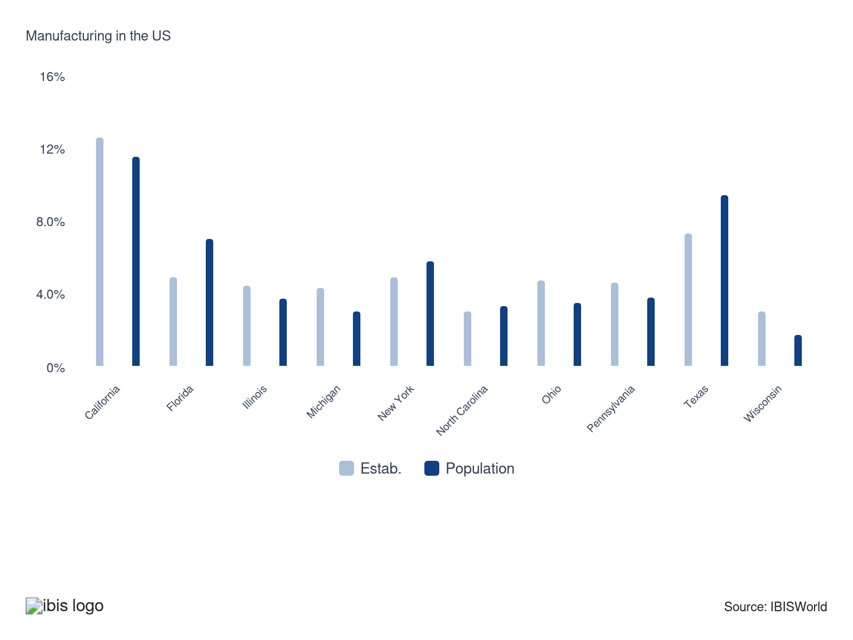

How do businesses use location to their advantage?
Operate in a location that is close to key markets
Proximity to customers reduces transportation costs, enables faster delivery times and makes it easier to respond to market shifts. Manufacturers gain a significant competitive edge by being able to deliver products quickly and reliably.
Operate in a location with appropriate water supply, soil type and climate
Access to critical natural resources and optimal environmental conditions supports efficient and sustainable production, especially in industries such as food and beverage or materials manufacturing. Choosing the right geography minimizes risks associated with resource shortages or logistical challenges.

6. Competitive Forces
https://my.ibisworld.com/us/en/industry/31-33/competitive-forces

Key Takeaways
- Market share concentration in the manufacturing sector remains low, indicating a competitive environment with numerous companies. Barriers to entry are moderate, driven by the need for significant capital investment and adherence to regulatory requirements.
- The availability of substitute goods varies by industry, with some areas facing more competition than others. Buyer power is significant because of the high volume and value of transactions involved, leading to pressures for price reductions.

Concentration
Low

What impacts the industry’s market share concentration?

High M&A activity produces varied consolidation effects in US manufacturing
- Acquisitions and divestitures across the sector occur regularly, but the persistent emergence of specialty producers in areas such as medical devices and precision components limits overall market share concentration. Notable portfolio restructuring, such as General Electric’s sale of legacy units and investment in advanced manufacturing applications, demonstrates a continuous fluidity in competitive positioning that restricts the dominance of any single entity.
- This fragmentation restrains widespread pricing power, compelling each manufacturer to focus on specialized product differentiation or operational efficiency to maintain margin stability. Manufacturers attuned to strategic M&A that enables platform expansion in niche verticals can consolidate supply chain leverage, but absent broader roll-ups, the competitive field remains open to innovative entrants.

Intense price competition constrains profitability and upholds competitive pressure across the sector
- Differentiation based on advanced automation, customization and materials, such as the adoption of additive manufacturing for aerospace and automotive applications, heightens rivalry among manufacturers. Price-based rivalry, particularly in commodity categories like fabricated metals and plastics processing, limits outsize margin growth while equalizing market share distribution among established and emerging producers.
- Vigorous competition strengthens buyer power, particularly for large distributors and OEMs with diversified vendor bases. Manufacturers unable to counteract price erosion with automation or process improvements endure margin compression, but those advancing proprietary products and value-added services secure more stable revenue streams and resist commoditization.

Innovation cost structures raise substantial barriers to entry for new and smaller manufacturers
- Investments required for the adoption of industrial Internet of Things solutions, robotics and advanced quality assurance systems remain prohibitively expensive for smaller manufacturers seeking to address high-specification needs, such as aerospace-grade alloys or specialized semiconductor fabrication. Despite third-party equipment leasing options, capital requirements for large-scale process technology upgrades limit the entry of new competitors in high-value segments.
- This structural challenge entrenches incumbent advantages for established manufacturers with extensive R&D budgets and supply relationships. Emerging producers that leverage government-backed technology accelerators or benefit from vertical integration can overcome some barriers, though most new entrants remain relegated to lower-value or regionalized niches until they achieve scale, influencing the trajectory of innovation capacity industry-wide.

How do successful businesses handle concentration?
Optimize operating capacity
Efficient use of production resources directly impacts cost structure and allows producers to better withstand aggressive competition in concentrated industries. Keeping facilities operating at their best helps manufacturers maintain cost leadership and boosts profit margin.
Develop a wide and expanding product range
Offering a diverse portfolio enables manufacturers to appeal to multiple customer segments and reduce dependency on a single market or product line. Such breadth creates stability and can make it more difficult for competitors to dominate any one niche.

Barriers to Entry
Moderate | Increasing

What challenges do potential industry entrants face?

Legal
- Manufacturers face mandatory compliance with Environmental Protection Agency emissions standards, Occupational Safety and Health Administration workplace regulations and extensive local permitting processes, including facility-specific hazardous material handling certifications. Regulatory complexity significantly increases time to market and ongoing compliance costs for new entrants, fortifying incumbent competitive advantage.

Start-Up costs
- The sector demands outlays for advanced automation equipment, precision tooling and strict adherence to process safety systems. Establishing a competitive facility often involves custom integration of production lines and cyber-physical controls. Large-scale investment in process analytics or robotics places incumbent producers at a cost advantage over smaller new entrants with limited resources.

Differentiation
- Manufacturers leverage proprietary additive manufacturing techniques, patented metallurgical compositions and exclusive supply chain relationships. For example, the precision aerospace components produced using unique powder bed fusion processes remain protected by intellectual property, presenting new market participants with formidable technological and branding barriers.

Capital Expenses
- The sector’s reliance on automated CNC machinery, high-throughput robotics and specialized engineering expertise necessitates significant capital allocation and access to niche labor pools, such as advanced materials scientists or certified automation technicians. Incumbents’ control over these assets restricts the speed and feasibility of new competitive entries, reinforcing established market positions.

How can potential entrants overcome barriers to entry?
Secure economies of scale
Achieving cost advantages through large-scale production makes it difficult for new entrants to compete on price. Established manufacturers leverage their scale to negotiate better terms with suppliers and attribute lower costs per unit across high output.
Protect intellectual property and copyright output
Safeguarding proprietary technologies or designs discourages imitation and raises the difficulty new competitors face entering the market. Intellectual property protections allow manufacturers to capitalize on their innovations without immediate competitive threats.

Substitutes
Moderate | Increasing

What are substitutes for industry services?

Imports
- Imports represent a tangible substitute for domestic output in advanced machinery and electronics manufacturing. Automotive assemblers and consumer electronics OEMs frequently secure components or finished goods from East Asian producers to cut costs and access advanced specifications. US-China tariffs and local content requirements moderate this trend, though the USMCA encourages North American sourcing for vehicle production.
- Elevated adoption of imports constrains pricing power for US producers and compresses output profit during periods of strong dollar exchange rates. Resilience for domestic manufacturers rests on tailoring high-mix, time-sensitive, or regulated products, medical devices specified under FDA traceability rules, for instance, where foreign alternatives face logistical or compliance barriers. Investment in proprietary process automation and supplier integration further anchors these customer segments.

In House
- Large-scale manufacturers in industries such as aerospace or industrial equipment internalize key fabrication processes, producing critical subsystems and components in proprietary facilities. This vertical integration is incentivized by requirements for stringent quality control, intellectual property security and just-in-time delivery. Government procurement contracts and defense manufacturing programs, such as the Defense Production Act, provide regulatory encouragement.
- The shift to in-house capabilities restricts addressable revenue streams for third-party suppliers and contract assemblers, increasing competitive intensity and driving down pricing. To safeguard relevance with these customers, manufacturing service providers can develop specialized process know-how and certifications, weld qualification for commercial aviation or ITAR compliance in defense, to serve as indispensable partners for functions that remain outsourced.

Do-it-yourself
- Additive manufacturing platforms and distributed CNC machining networks empower small businesses and R&D operations to produce custom fixtures, housings and replacement parts without engaging traditional manufacturers. Open-source CAD libraries and direct-to-machine print services reduce barriers to entry and turnaround time, particularly for maintenance, repair and operations in industries like energy or logistics.
- Wide adoption of in-house prototyping erodes demand for standard part suppliers and small-batch manufacturing shops. Sustained relevance for the latter lies in advancing post-processing expertise, accredited material testing and just-in-time inventory solutions. Positioning as a collaborative partner that can integrate with customers’ design and prototyping cycles helps mitigate volume loss from this substitution trend.

How do successful businesses compete with substitutes?
Produce a differentiated product
Offering a product that stands out in terms of design, features, or quality makes it harder for substitutes to lure customers away. By emphasizing unique value that alternatives simply can't match, manufacturers can create brand loyalty and reduce price sensitivity.
Invest in research and development
Continual innovation allows manufacturers to stay ahead of industry trends and respond quickly to emerging substitutes. Advancements through R&D strengthen a manufacturer’s ability to introduce improved or entirely new products that keep customers engaged and loyal.

Buyer & Supplier Power
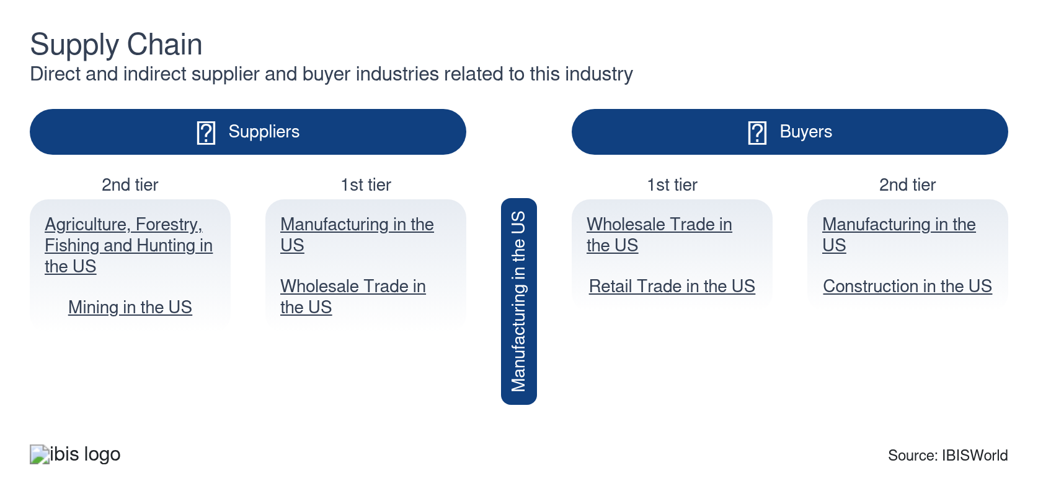

What power do buyers and suppliers have over the industry?

Buyers: Buyers’ concentration intensify price competition
High | Steady
- Large-scale purchasers in the sector, including automakers and electronics assemblers, employ highly sophisticated supplier evaluation frameworks. These methods often incorporate real-time inventory integration and stringent quality metrics, resulting in extended payment terms and volume-based discounting. Customer concentration, particularly in capital goods or automotive supply chains, enables these buyers to negotiate requirements for custom tooling or tailored logistics services.
- To offset heightened buyer leverage, the sector has adopted co-development projects and advanced customer integration services within sales agreements. Manufacturers integrate product lifecycle management tools and offer embedded technical support, supporting customer retention efforts despite intensified margin pressure. Strategic responses such as value-added engineering strengthen supplier relationships but compress pricing flexibility for commodity-grade manufacturers.

Suppliers: Input material concentration require aggressive risk mitigation
High | Steady
- Suppliers of specialty alloys, industrial resins and precision control electronics maintain a high degree of market concentration, supported by proprietary production technology and strict regulatory certification. The predominance of annual or multi-year fixed price agreements shifts exposure to input price fluctuations onto manufacturers, constraining the ability to transfer increased costs to end customers.
- To manage supplier power, the sector has increased investment in multi-sourcing strategies, developed alternative materials and partially executed vertical integration, especially in electronics and machining segments. These measures help secure continuity of supply during disruptions and reduce sensitivity to supplier pricing volatility.

How do successful businesses manage buyer & supplier power?
Establish long-term working relationships with raw material suppliers
Maintaining reliable partnerships ensures consistent access to necessary materials and reduces vulnerability to supplier-driven price hikes. Strong relationships often lead to preferential treatment, cost savings and improved negotiation outcomes.
Develop an extensive distribution network
A broad network increases a manufacturer’s bargaining power with buyers by reaching more customers and reducing dependency on a few key channels. Wider distribution provides flexibility to shift volumes as market dynamics or buyer demands change.

7. Companies
https://my.ibisworld.com/us/en/industry/31-33/companies

No single company accounts for more than 5% of total industry market share.

8. External Environment
https://my.ibisworld.com/us/en/industry/31-33/external-environment

Key Takeaways
- Regulatory frameworks significantly influence the manufacturing sector, spanning environmental, health and safety standards. Compliance with these regulations necessitates substantial investment, impacting profit. Nonetheless, rigorous standards also drive innovation and quality improvements within the sector.
- Government support through subsidies, tax incentives and grants is crucial for the manufacturing sector. Such assistance helps offset operational costs and encourage investment in new technologies. Industry associations also offer resources and guidance to navigate regulatory challenges and market dynamics.

External Drivers

What demographic and macroeconomic factors impact the industry?
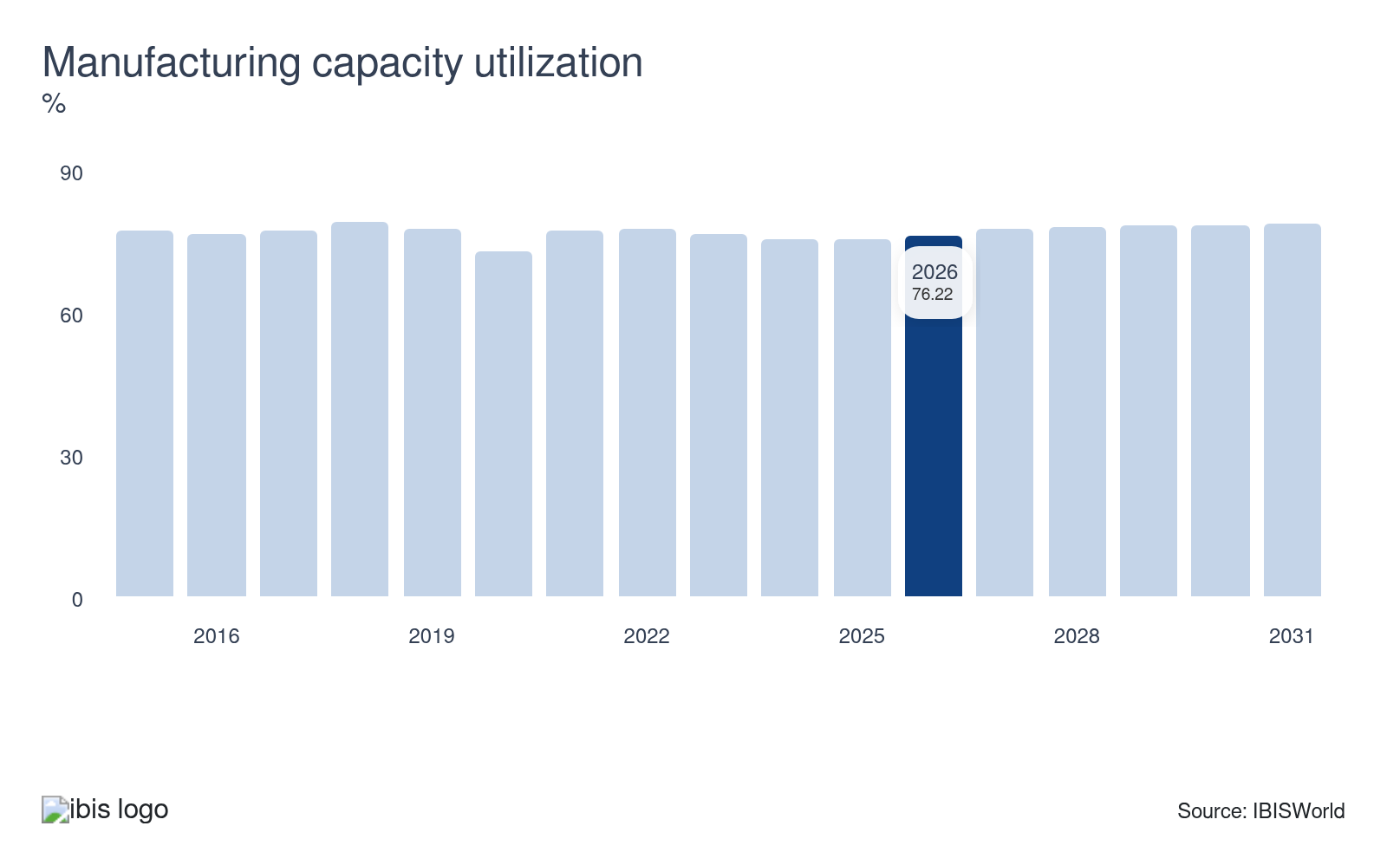
Manufacturing capacity utilization measures how fully manufacturers are using their production capabilities. Higher utilization rates indicate strong demand and efficient resource use, often leading to increased investments and expansion. Lower rates suggest underutilized capacity and potential overproduction, which can reduce profit and lead to scaling back operations. Monitoring capacity helps companies make strategic decisions regarding production and investment. Declines in manufacturing capacity utilization pose a potential threat to the sector.
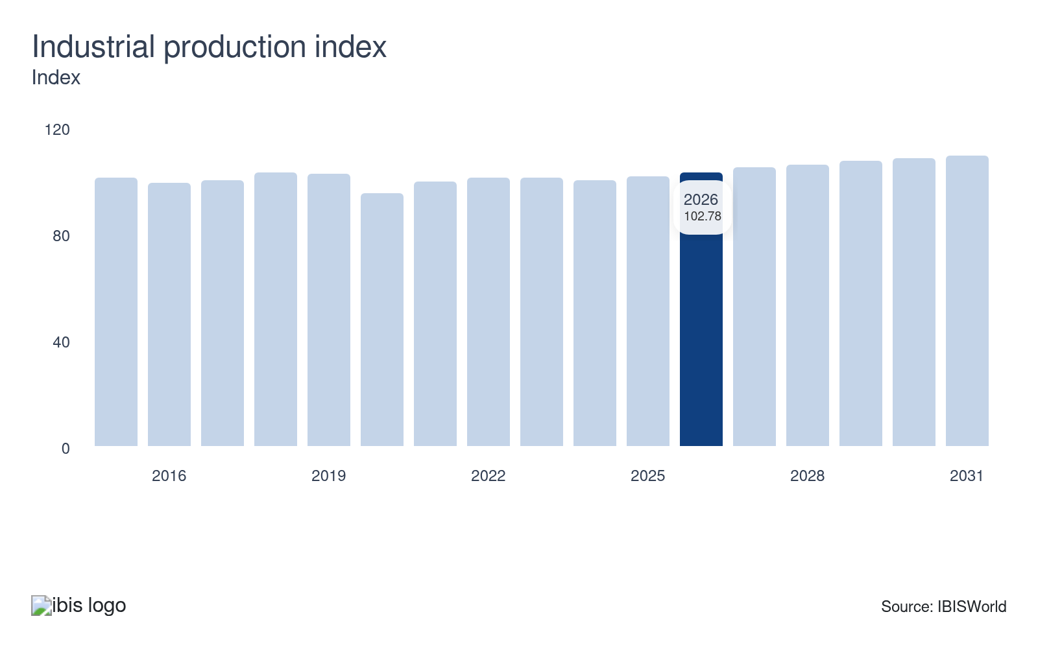
The industrial production index measures the actual output of manufacturing and other industrial sectors. An increasing index signals higher production levels and corresponds with economic growth and increased demand for manufactured goods. A decreasing index suggests reduced production, indicating an economic slowdown or decreased demand. Growth in the industrial production index represents a potential opportunity for the sector.
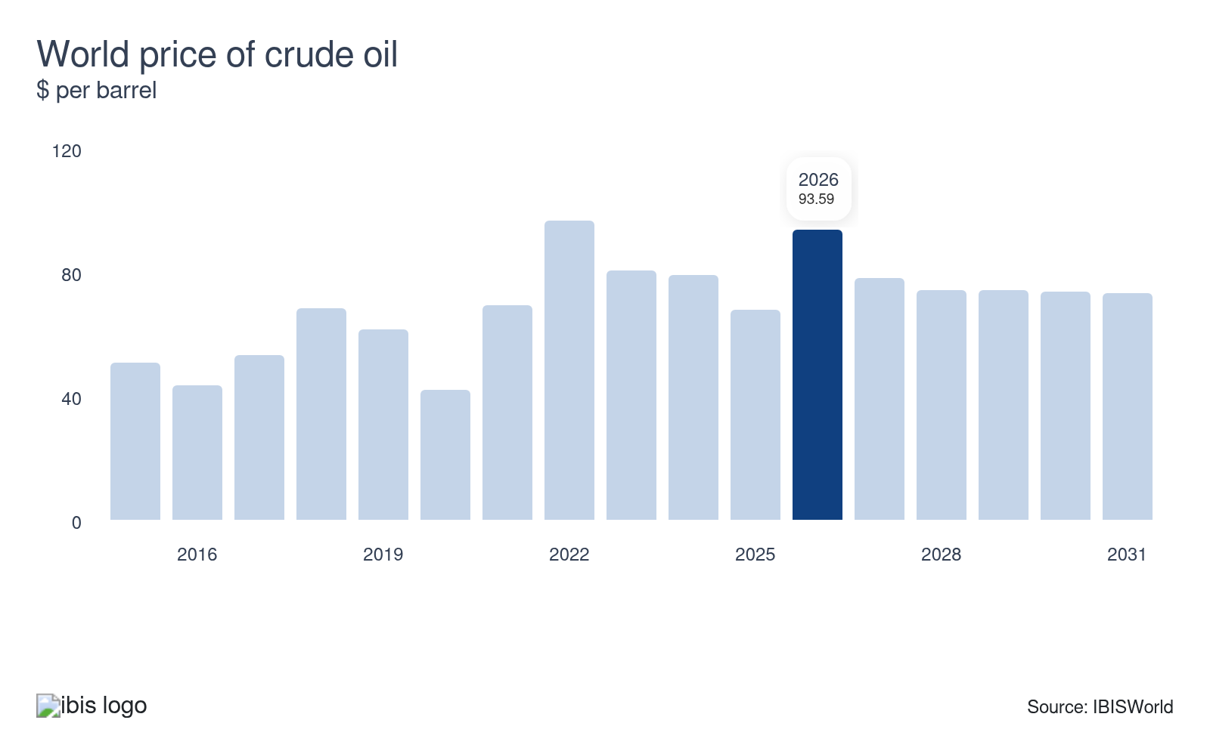
The world price of crude oil affects manufacturing costs because energy and transportation expenses are significant components of production budgets. Higher crude oil prices boost operational costs, leading to higher prices for manufactured goods. Lower oil prices reduce these costs and enable manufacturers to offer products at more competitive prices. Fluctuations in crude oil prices can cause variability in profit and pricing strategies.
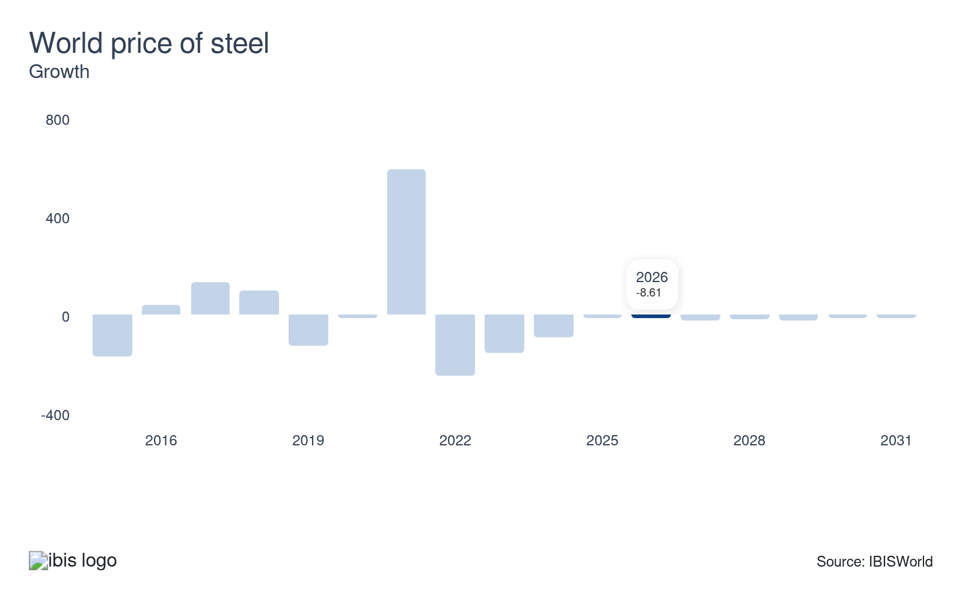
The world price of steel significantly impacts manufacturing because steel is a primary raw material for many products. Increases in steel prices raise production costs, which can lead to higher prices for finished goods. Decreased steel prices lower production costs, allowing manufacturers to increase their profit or reduce prices to gain market share. These steel price fluctuations directly influence the supply chain and pricing strategies.
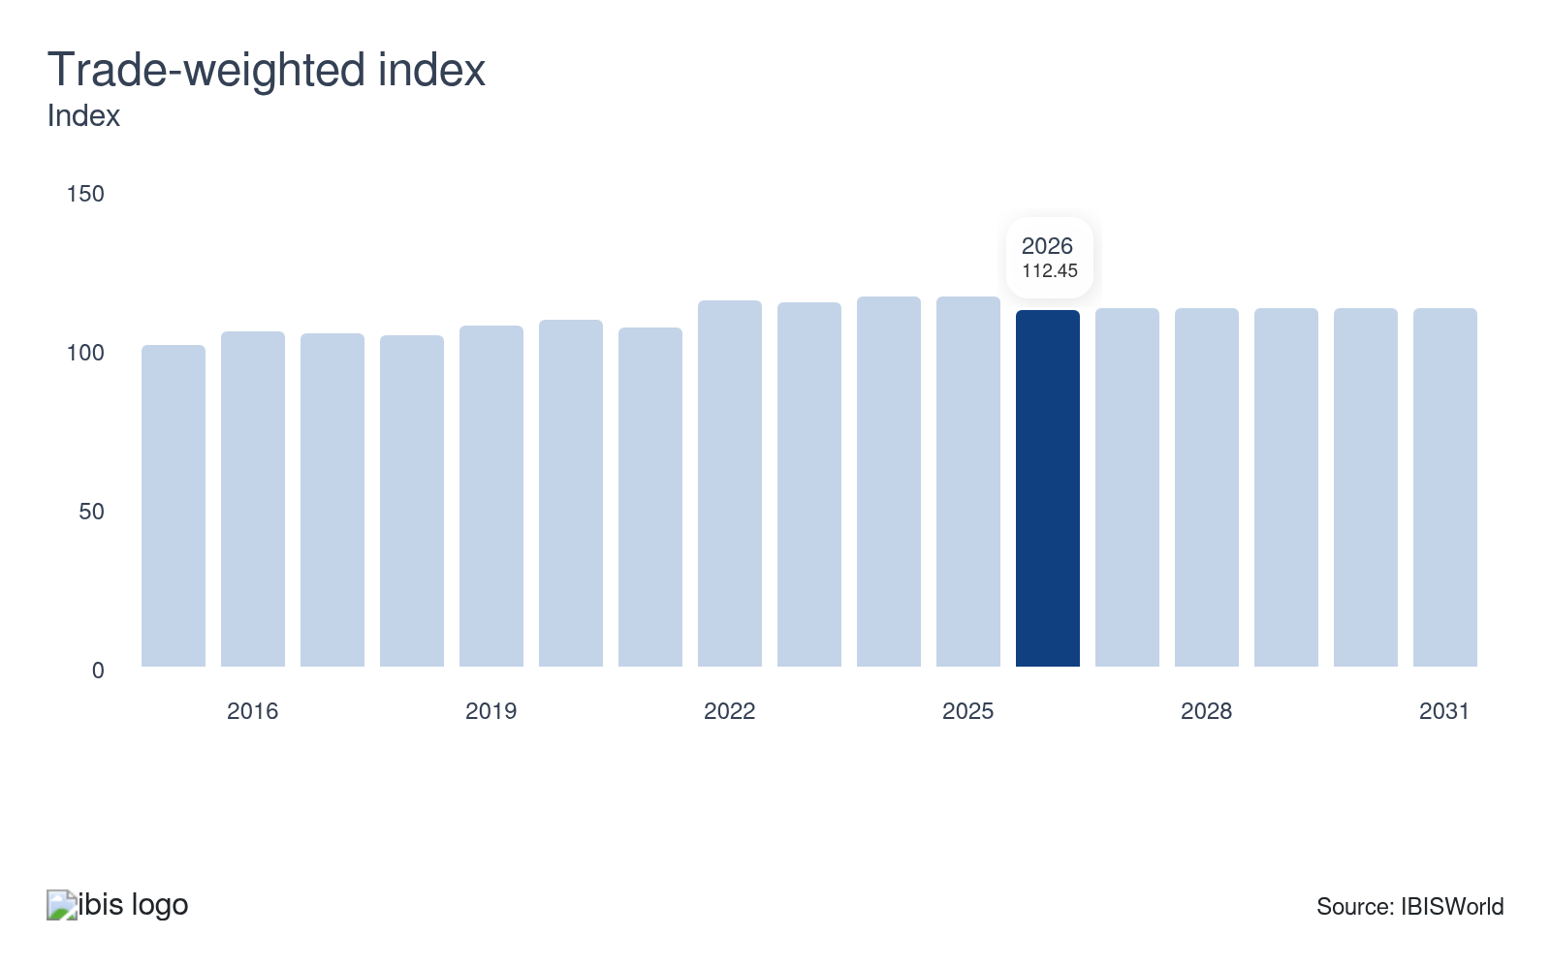
Changes in the trade-weighted index, which measures the value of the US dollar against other major currencies, directly impact manufacturing competitiveness. A stronger dollar makes US goods more expensive abroad, reducing export demand. Conversely, a weaker dollar boosts exports by making US products more affordable for international buyers. These fluctuations influence production rates, employment levels and profit in the manufacturing sector.

Regulation & Policy
High | Increasing

What regulations impact the industry?

Clean Air Act (CAA)
The Clean Air Act imposes strict emissions limits and reporting requirements on producers, affecting operations through mandatory installation of pollution control equipment and regular compliance documentation. The enforcement action against Volkswagen and US-based diesel engine manufacturers highlights the regulatory risk and financial exposure tied to non-compliance. Amendments and evolving EPA rulemakings on greenhouse gases, especially after the introduction of National Ambient Air Quality Standards for ozone, have significantly increased the compliance burden. Smaller manufacturers struggle with the capital intensity of emissions abatement relative to larger or multinational counterparts. On February 7, 2024, the EPA finalized a rule tightening the primary annual PM₂.₅ National Ambient Air Quality Standard to 9.0 µg/m³, with the change becoming effective on May 6, 2024, strengthening health-based air-quality limits nationwide.

Occupational Safety and Health Act (OSHA)
The Occupational Safety and Health Act mandates strict workplace safety standards and comprehensive record-keeping in US manufacturing. Enforcement actions, such as penalties levied for violations in auto parts production and machinery operations, reveal the direct financial consequences of non-compliance. Ongoing regulatory updates, including new guidelines for handling chemicals and automation-driven hazards, require adjustments in training and process design. Compliance complexity increases for smaller manufacturers, who may lack the dedicated resources for extensive documentation and ongoing monitoring compared to larger producers. Industry lobbying has focused on moderating chemical exposure standards and shifting inspection protocols. OSHA published a final rule revising its personal protective equipment standard for construction on December 11, 2024, explicitly requiring employers to provide properly fitting PPE for construction workers, with the change taking effect on January 13, 2025.

Toxic Substances Control Act (TSCA)
The Toxic Substances Control Act regulates chemical management in manufacturing, requiring upfront notification, risk assessments and removal of hazardous substances. Amendments through the Frank R. Lautenberg Chemical Safety Act expanded EPA oversight, leading to new restrictions on chemicals such as asbestos in industrial components. Enforcement pursuits targeting electronics and specialty materials manufacturers reflect compliance risks. Larger manufacturers tend to internalize compliance with dedicated staff, while small and mid-sized producers may outsource or scale back product offerings. The regulation’s extensive testing and reporting mandates push research into safer alternatives and directly shape innovation in paints, adhesives and polymers. The EPA finalized amendments to the new-chemicals regulations under TSCA on December 18, 2024, tightening review procedures, narrowing or removing certain low-volume/low-release exemptions (including for PFAS) and requiring explicit EPA authorization before manufacture under some exemptions, to strengthen pre-manufacture review.

Export Administration Regulations (EAR)
The Export Administration Regulations control the international transfer of manufactured goods with dual-use or sensitive military applications. Direct impacts include licensing requirements, restrictions on supplying sanctioned foreign entities and obligations for record-keeping and end-use verification. Enforcement cases involving technology exports to embargoed countries have resulted in substantial penalties for US manufacturers. Rule updates, particularly those expanding controls on semiconductors and aerospace components, increase the strategic complexity of global supply chain management. Small producers face disproportionate compliance costs and heightened transaction risk. Expanding export controls hinder international sales opportunities but stimulate domestic investment in manufacturing certain high-specification products, such as advanced microprocessors for defense applications. The Bureau of Industry and Security issued an interim final rule effective July 18, 2024, revising the scope and terminology for “standards-related activities” subject to the EAR and also made further Entity-List amendments effective March 25, 2025.

Assistance
High | Steady

What assistance is available to this industry?

Federal Research and Development Tax Credit (R&D Tax Credit)
The Federal Research and Development Tax Credit enables US manufacturers to offset qualified R&D expenses. This instrument supports investment in process innovation, component testing and automation upgrades, often adopted by manufacturers of electronics, aerospace components and automotive assemblies. Uptake is highest among manufacturers with dedicated R&D functions, while smaller producers struggle with administrative complexity and uncertainty over qualifying expenses. Use of this credit has bolstered investment in proprietary technology platforms and improved product differentiation versus low-cost imports. Widespread utilization remains impeded by compliance costs, prompting strategic consolidation of R&D functions among mid-sized manufacturers.

Manufacturing Extension Partnership (MEP)
The Manufacturing Extension Partnership, led by the National Institute of Standards and Technology, provides technical and operational consultancy to US manufacturers aiming to enhance supply chain resilience, quality management and digitization. Operational benefit includes direct onsite support for advanced robotics integration and Lean manufacturing, particularly for fabricated metals and plastics producers. Utilization is robust among mid-cap and lower-mid market manufacturers, but micro-manufacturers often lack awareness or believe fees outweigh returns. The program’s facilitation of modernized production lines and quality certification adoption has demonstrably reinforced export competitiveness for supported manufacturers.

Advanced Energy Manufacturing and Recycling Grant Program
The Advanced Energy Manufacturing and Recycling Grant Program, administered by the Department of Energy, funds projects that retrofit US manufacturing facilities for energy efficiency, electrification and renewable component production. Programs have catalyzed capacity expansion in battery system subcomponents and solar module manufacturing. Adoption skews toward large-scale base-materials manufacturers because of grant size requirements and co-investment terms, while labor-intensive segments report limited access. Documented gains include upgrades supporting compliance with the Inflation Reduction Act’s domestic content incentives and measurable reductions in energy input costs across grant recipients’ operations.

National Association of Manufacturers (NAM)
NAM provides manufacturers access to extensive advocacy, professional development programs and regulatory information tailored to operational and workforce challenges. Uptake is broad, with substantial membership among small and large manufacturers, particularly those seeking national influence or real-time compliance resources. Barriers include limited participation from smaller producers who perceive insufficient relevance to niche production needs or lack resources for annual dues. NAM’s industry initiatives, such as the Manufacturing Institute’s workforce training, have facilitated structured skills development across multiple regions, contributing to increased labor readiness.

Reshoring Initiative
The Reshoring Initiative delivers data-driven support and tools enabling domestic producers to calculate the total cost of ownership, benchmark supply chain risks and connect with skilled suppliers. A growing number of manufacturers have leveraged the Total Cost of Ownership Estimator to underpin supply chain realignment, though usage is more concentrated among medium-sized operations with complex sourcing dependencies. Key challenges are limited awareness among legacy manufacturers and difficulty integrating tools with existing ERP systems. Adoption of these analytics has contributed to expanded domestic sourcing for select subsectors, reinforcing supply chain agility.

Manufacturing Leadership Council
The Manufacturing Leadership Council operates as a peer-driven network providing strategic benchmarking, advanced manufacturing education and digital transformation frameworks. Applicability is strongest among producers investing in automation, IIoT and smart factory concepts. Despite strong uptake from digitization-focused manufacturers, high membership costs and intensive peer-to-peer engagement requirements hinder broader access, especially for resource-constrained producers. Participation has facilitated agreement on operational best practices in advanced manufacturing, directly impacting technology adoption rates and establishing reference architectures within the sector.

9. Financial Benchmarks
https://my.ibisworld.com/us/en/industry/31-33/financial-benchmarks
Profit Margin  6.9 %  ↓ Lower than sector | Average Wage  $74,559  ↓ Lower than sector | Largest Cost  Purchases  53.7% of Revenue

Key Takeaways
- Profit in the manufacturing sector has faced downward pressure from rising operations costs and R&D fees. Maintaining viable profit levels requires companies to innovate and continuously optimize efficiency. Despite these efforts, shrinking profit remains a concern for many companies.
- Wages form a significant component of the cost structure in the manufacturing sector. Companies rely on skilled labor, contributing to relatively high wage expenses compared to other sectors. Investing in workforce training and development is essential to stay competitive.

Cost Structure
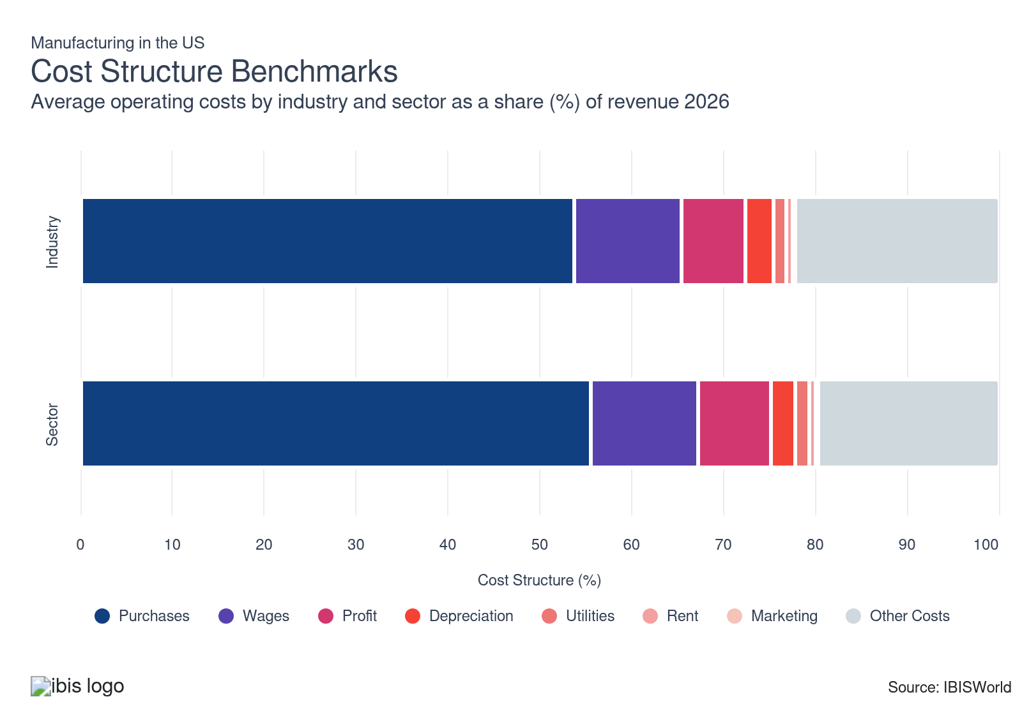
Chart displays current year only in the PDF version of this report. You can view and download chart for all other years associated with this industry on my.ibisworld.com.

What trends impact industry costs?

Profit levels reflect competitive cost pressures and limited pass-through capability for input costs
- Profit as a share of revenue in the industry has seen only a minor uptick over the past five years. Producers have not been able to fully offset higher input and logistics costs because many manufacturing verticals, such as automotive components and industrial machinery, face contract pricing lock-ins and highly price-sensitive downstream buyers. These constraints continue to limit profit improvement and suppress price-setting flexibility.
- High material volatility and labor cost pressures have led many manufacturers to accelerate plant automation and deploy more advanced ERP systems to better manage costs. While this has yielded incremental operational efficiency, the cost savings have been largely offset by sustained raw-material inflation and increased compliance expenses associated with reshoring. The trend in profit remains relatively flat, with only marginal change.

Wage dynamics remain pressured by skilled labor shortages and union-driven negotiations
- Wages have declined negligibly as a percentage of industry revenue over the last five years. Manufacturers reliant on electricians, CNC machinists and robotics technicians are encountering persistent shortages due to low technical program graduation rates and an aging workforce. The USMCA has contributed to wage stabilization in specific regions, especially those near the automotive corridor.
- In response, many manufacturers have shifted non-core production overseas when possible, implemented digital upskilling programs on shop floors and invested in advanced robotics to limit overtime exposure. Despite these mitigations, skilled labor remains structurally under-supplied, prompting leaner staffing models and higher retention costs in key manufacturing clusters. The trend in wage share shows a marginal reduction, driven by efficiency gains rather than reduced wage rates.

Depreciation expenses signal stable asset replacement cycles with early bets on capital-intensive automation
- Depreciation as a proportion of revenue has held steady, reflecting stable equipment replacement patterns despite significant capital expenditure announcements. Large manufacturers in durable goods and semiconductor fabrication upgraded machinery to integrate robotics and AI-enabled process controls, particularly in response to post-pandemic supply disruptions.
- While automation broadens capabilities in high-specification product classes such as precision medical devices, the pace of asset write-downs and replacement remains in equilibrium with previous cycles. This stability indicates that large-scale new investments are deliberate rather than reactionary.

Procurement cost volatility drives renewed focus on supplier diversification and raw input substitution
- Purchases, primarily raw metals (aluminum, steel), electronics, resins and industrial chemicals, have become increasingly volatile, with the overall cost share rising slightly over the past five years. Commodity price inflation in electronic components and steel, coupled with pandemic-era port congestion, has increased procurement costs, particularly in the automotive and aerospace verticals.
- Manufacturers have countered with dual-sourcing strategies, regionalizing supply chains for critical inputs and substituting with recycled or engineered materials where feasible, as seen in appliance production. Despite these moves, input and component prices remain high and subject to global shocks, driving the slight upward trend in purchase outlays relative to revenue.

Industrial space rent expenses remain subdued due to supply-demand balance in key manufacturing hubs
- Rent for production facilities and warehousing represents a consistently minor share of revenue, with no significant change over the last five years. Geographic shifts away from traditional high-cost industrial corridors toward secondary regions benefit from lower commercial real estate prices and aggressive tax incentives in states such as Tennessee and South Carolina.
- A surge in build-to-suit plant construction and manufacturers acquiring their own facilities, especially in semiconductor and battery manufacturing, has further constrained rent growth. Rent cost share has remained flat, reflecting the abundance of space and strategic ownership trends.

Utilities cost stability reflects energy efficiency investments and increased renewables penetration
- Utilities expenses have decreased marginally as a share of revenue. Industry-wide investment in more energy-efficient equipment, such as variable-speed drives and advanced HVAC systems, has helped limit cost growth. Increased adoption of on-site solar and long-term power purchase agreements has also enabled predictable energy pricing across sub-industries such as metal fabrication.
- Short-term natural gas price shocks occurred, but hedging strategies buffered manufacturers from volatility, especially for operations with heavy heating or refrigeration use. Overall, efficiency initiatives and energy diversification have produced a slight downward trend in utility costs for the industry.

Marketing expenditures reflect an entrenched emphasis on OEM relationships over consumer branding
- Marketing expenses have remained exceedingly low as a share of revenue, consistent with the focus on direct sales relationships between manufacturers and OEMs or distributors. With most industry output provided under contract or long-term agreements, demand for B2B marketing activities, such as trade shows, digital catalogs and technical product demonstrations, dominates spend.
- Emerging investments in digital configurators or virtual samples have slightly raised spending in sub-industries like machine tools, but cost controls persistently limit overall marketing outlays. The share of revenue dedicated to marketing has not changed materially over the review period.

Other costs highlight increased insurance, compliance, and logistics spending amid tighter regulatory scrutiny
- Other costs, encompassing insurance, logistics management and regulatory compliance, continue to account for a substantial share of industry expenses, though the share has declined modestly over five years. The intensified focus on product traceability, notably in aerospace manufacturing, has increased documentation requirements and associated system investments.
- Producers have partially offset these outlays through investments in digital logistics platforms and consolidated customs brokerage arrangements, reducing administrative burden. Continued tightening of safety and environmental requirements is likely to restrain further cost decline, but the overall trend for other costs has been a modest drop due to operational streamlining.
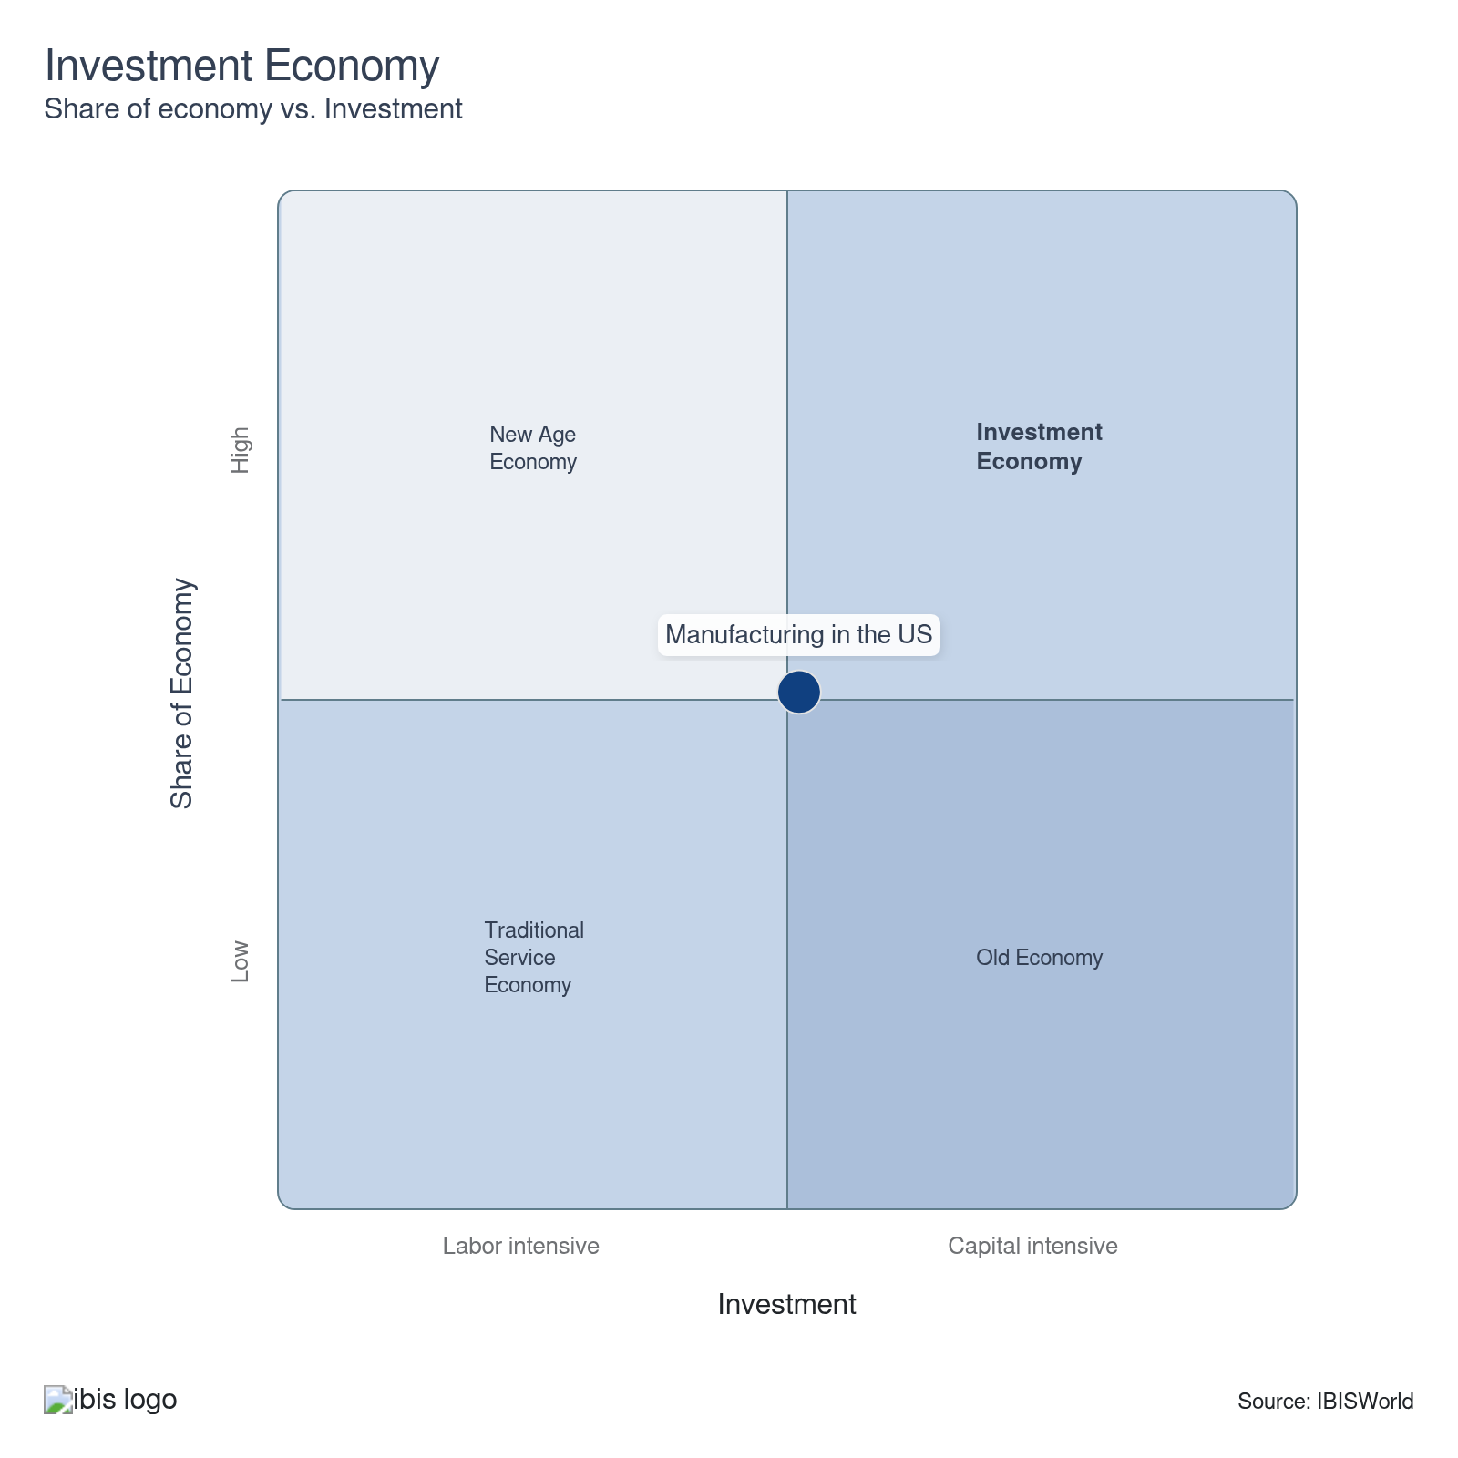

Key Ratios
Year | Revenue per Employee  ($) | Revenue per Enterprise  ($ Million) | Employees per Estab.  (Units) | Employees per Enterprise  (Units) | Average Wage  ($) | Wages/ Revenue  (%) | Estab. per Enterprise  (Units) | IVA/ Revenue  (%) | Imports/ Demand  (%) | Exports/ Revenue  (%)
2005 | 564,787 | 13.0 | 21.3 | 23.0 | 69,121 | 12.2 | 1.1 | 21.8 | 25.3 | 14.9
2006 | 586,563 | 13.1 | 20.7 | 22.3 | 69,248 | 11.8 | 1.1 | 21.6 | 26.4 | 16.3
2007 | 587,872 | 13.1 | 20.8 | 22.4 | 67,837 | 11.5 | 1.1 | 21.2 | 26.3 | 17.0
2008 | 621,558 | 13.6 | 20.4 | 21.9 | 68,834 | 11.1 | 1.1 | 19.4 | 26.6 | 18.2
2009 | 581,121 | 11.3 | 18.0 | 19.4 | 69,723 | 12.0 | 1.1 | 21.0 | 25.8 | 18.1
2010 | 660,776 | 12.4 | 17.5 | 18.8 | 72,531 | 11.0 | 1.1 | 21.2 | 28.1 | 19.4
2011 | 716,645 | 13.4 | 17.5 | 18.7 | 72,842 | 10.2 | 1.1 | 20.1 | 28.7 | 20.1
2012 | 691,252 | 13.3 | 18.0 | 19.2 | 72,004 | 10.4 | 1.1 | 20.5 | 28.9 | 20.3
2013 | 700,631 | 13.5 | 18.0 | 19.2 | 72,848 | 10.4 | 1.1 | 20.4 | 28.7 | 20.2
2014 | 703,167 | 13.3 | 17.7 | 18.8 | 73,686 | 10.5 | 1.1 | 20.9 | 29.4 | 20.2
2015 | 643,421 | 12.2 | 17.8 | 19.0 | 74,172 | 11.5 | 1.1 | 22.5 | 30.6 | 20.1
2016 | 621,764 | 11.9 | 17.9 | 19.1 | 74,710 | 12.0 | 1.1 | 23.2 | 30.7 | 19.5
2017 | 626,611 | 12.3 | 18.3 | 19.6 | 74,499 | 11.9 | 1.1 | 23.0 | 30.9 | 19.5
2018 | 628,054 | 12.5 | 18.6 | 20.0 | 73,884 | 11.8 | 1.1 | 22.9 | 31.7 | 19.6
2019 | 606,279 | 12.1 | 18.5 | 19.9 | 74,465 | 12.3 | 1.1 | 23.2 | 31.9 | 19.6
2020 | 553,913 | 10.8 | 18.2 | 19.5 | 74,049 | 13.4 | 1.1 | 24.5 | 32.6 | 18.3
2021 | 623,481 | 11.9 | 17.7 | 19.0 | 74,631 | 12.0 | 1.1 | 21.4 | 33.1 | 18.7
2022 | 651,569 | 12.7 | 18.1 | 19.5 | 72,114 | 11.1 | 1.1 | 19.8 | 32.5 | 18.4
2023 | 624,433 | 12.2 | 18.1 | 19.5 | 72,109 | 11.5 | 1.1 | 20.6 | 31.6 | 18.3
2024 | 624,646 | 12.0 | 17.8 | 19.1 | 72,705 | 11.6 | 1.1 | 20.7 | 32.8 | 18.4
2025 | 633,830 | 11.9 | 17.5 | 18.8 | 74,629 | 11.8 | 1.1 | 21.2 | 33.6 | 18.7
2026 | 630,946 | 11.8 | 17.3 | 18.6 | 74,559 | 11.8 | 1.1 | 21.7 | 32.9 | 19.0
2027 | 632,471 | 11.8 | 17.3 | 18.6 | 74,595 | 11.8 | 1.1 | 21.7 | 32.7 | 19.1
2028 | 632,597 | 11.7 | 17.3 | 18.6 | 74,598 | 11.8 | 1.1 | 21.6 | 32.7 | 19.1
2029 | 633,087 | 11.7 | 17.3 | 18.5 | 74,610 | 11.8 | 1.1 | 21.6 | 32.7 | 19.1
2030 | 634,581 | 11.8 | 17.3 | 18.5 | 74,645 | 11.8 | 1.1 | 21.6 | 32.7 | 19.2
2031 | 635,672 | 11.8 | 17.2 | 18.5 | 74,671 | 11.7 | 1.1 | 21.6 | 32.8 | 19.1
2032 | 637,221 | 11.8 | 17.2 | 18.5 | 74,707 | 11.7 | 1.1 | 21.6 | 32.8 | 19.1
*Figures are inflation adjusted to 2026
*Figures are inflation adjusted to 2026

10. Key Statistics
https://my.ibisworld.com/us/en/industry/31-33/key-statistics

Industry Data

Values
Year | Revenue  ($ Million) | IVA  ($ Million) | Estab.  (Units) | Enterprises  (Units) | Employment  (Units) | Exports  ($ Million) | Imports  ($ Million) | Wages  ($ Million)
2005 | 7,601,695.6 | 1,658,358.7 | 630,994 | 586,102 | 13,459,414 | 1,135,400.8 | 2,194,041.7 | 930,333.3
2006 | 7,798,825.0 | 1,681,142.6 | 642,173 | 597,150 | 13,295,807 | 1,271,932.9 | 2,343,959.7 | 920,703.1
2007 | 8,081,254.3 | 1,710,786.0 | 659,415 | 614,761 | 13,746,629 | 1,373,062.8 | 2,392,924.8 | 932,535.8
2008 | 8,119,322.3 | 1,573,038.2 | 640,709 | 596,137 | 13,062,854 | 1,478,473.1 | 2,410,002.5 | 899,165.1
2009 | 6,524,375.0 | 1,371,353.5 | 622,129 | 579,370 | 11,227,230 | 1,180,270.1 | 1,854,165.6 | 782,801.8
2010 | 7,153,268.0 | 1,514,591.6 | 618,391 | 577,071 | 10,825,555 | 1,384,646.1 | 2,253,858.7 | 785,193.5
2011 | 7,830,257.3 | 1,574,537.5 | 625,428 | 584,726 | 10,926,264 | 1,571,490.0 | 2,520,648.6 | 795,891.0
2012 | 7,990,061.1 | 1,641,632.9 | 641,879 | 601,021 | 11,558,823 | 1,618,355.7 | 2,592,152.4 | 832,280.7
2013 | 8,011,539.5 | 1,630,521.0 | 635,119 | 594,882 | 11,434,746 | 1,618,457.1 | 2,567,497.5 | 832,994.8
2014 | 7,980,385.7 | 1,670,730.5 | 642,889 | 602,247 | 11,349,208 | 1,611,387.8 | 2,649,079.5 | 836,274.2
2015 | 7,414,612.7 | 1,667,874.9 | 648,292 | 607,241 | 11,523,731 | 1,487,851.3 | 2,609,933.3 | 854,740.7
2016 | 7,126,600.4 | 1,650,545.1 | 640,689 | 599,108 | 11,461,910 | 1,392,450.4 | 2,542,917.6 | 856,314.1
2017 | 7,342,959.1 | 1,692,428.3 | 639,412 | 596,515 | 11,718,525 | 1,428,265.3 | 2,644,798.5 | 873,020.5
2018 | 7,528,735.0 | 1,724,837.3 | 644,192 | 600,255 | 11,987,392 | 1,477,077.7 | 2,812,708.8 | 885,682.4
2019 | 7,210,948.2 | 1,670,370.2 | 641,824 | 597,885 | 11,893,770 | 1,414,559.5 | 2,715,794.3 | 885,665.7
2020 | 6,459,841.9 | 1,585,528.6 | 640,495 | 596,578 | 11,662,195 | 1,183,734.9 | 2,556,605.2 | 863,578.7
2021 | 7,216,417.0 | 1,547,696.7 | 652,927 | 607,852 | 11,574,394 | 1,346,342.4 | 2,904,546.4 | 863,811.7
2022 | 7,809,127.9 | 1,550,014.0 | 661,249 | 615,014 | 11,985,108 | 1,438,593.3 | 3,066,756.6 | 864,293.8
2023 | 7,526,720.3 | 1,549,428.6 | 664,854 | 618,147 | 12,053,685 | 1,374,806.2 | 2,836,103.2 | 869,176.8
2024 | 7,424,105.6 | 1,533,343.4 | 667,624 | 620,743 | 11,885,301 | 1,369,175.8 | 2,953,473.0 | 864,121.8
2025 | 7,405,209.3 | 1,570,013.6 | 668,804 | 622,087 | 11,683,274 | 1,385,844.1 | 3,040,321.9 | 871,911.2
2026 | 7,300,211.5 | 1,584,280.6 | 667,186 | 621,052 | 11,570,262 | 1,388,982.5 | 2,896,656.8 | 862,668.0
2027 | 7,353,659.8 | 1,593,641.8 | 671,374 | 624,900 | 11,626,874 | 1,405,865.1 | 2,893,786.9 | 867,307.9
2028 | 7,375,572.8 | 1,596,383.8 | 674,901 | 628,272 | 11,659,193 | 1,410,934.5 | 2,899,289.9 | 869,753.5
2029 | 7,412,043.3 | 1,602,477.4 | 678,159 | 631,299 | 11,707,785 | 1,418,796.2 | 2,910,494.8 | 873,513.5
2030 | 7,461,732.7 | 1,611,169.1 | 681,450 | 634,292 | 11,758,520 | 1,429,199.4 | 2,926,856.8 | 877,713.0
2031 | 7,495,530.4 | 1,616,470.4 | 684,129 | 636,771 | 11,791,501 | 1,430,492.1 | 2,958,426.4 | 880,477.6
2032 | 7,557,602.6 | 1,629,083.0 | 687,831 | 640,105 | 11,860,260 | 1,441,207.8 | 2,986,957.6 | 886,043.3

*Figures are inflation adjusted to 2026

Annual Change
Year | Revenue  % | IVA  % | Estab.  % | Enterprises  % | Employment  % | Exports  % | Imports  % | Wages  %
2005 | N/A | N/A | N/A | N/A | N/A | N/A | N/A | N/A
2006 | 2.6 | 1.4 | 1.8 | 1.9 | -1.2 | 12.0 | 6.8 | -1.0
2007 | 3.6 | 1.8 | 2.7 | 2.9 | 3.4 | 8.0 | 2.1 | 1.3
2008 | 0.5 | -8.1 | -2.8 | -3.0 | -5.0 | 7.7 | 0.7 | -3.6
2009 | -19.6 | -12.8 | -2.9 | -2.8 | -14.1 | -20.2 | -23.1 | -12.9
2010 | 9.6 | 10.4 | -0.6 | -0.4 | -3.6 | 17.3 | 21.6 | 0.3
2011 | 9.5 | 4.0 | 1.1 | 1.3 | 0.9 | 13.5 | 11.8 | 1.4
2012 | 2.0 | 4.3 | 2.6 | 2.8 | 5.8 | 3.0 | 2.8 | 4.6
2013 | 0.3 | -0.7 | -1.1 | -1.0 | -1.1 | 0.0 | -1.0 | 0.1
2014 | -0.4 | 2.5 | 1.2 | 1.2 | -0.7 | -0.4 | 3.2 | 0.4
2015 | -7.1 | -0.2 | 0.8 | 0.8 | 1.5 | -7.7 | -1.5 | 2.2
2016 | -3.9 | -1.0 | -1.2 | -1.3 | -0.5 | -6.4 | -2.6 | 0.2
2017 | 3.0 | 2.5 | -0.2 | -0.4 | 2.2 | 2.6 | 4.0 | 2.0
2018 | 2.5 | 1.9 | 0.7 | 0.6 | 2.3 | 3.4 | 6.3 | 1.5
2019 | -4.2 | -3.2 | -0.4 | -0.4 | -0.8 | -4.2 | -3.4 | 0.0
2020 | -10.4 | -5.1 | -0.2 | -0.2 | -1.9 | -16.3 | -5.9 | -2.5
2021 | 11.7 | -2.4 | 1.9 | 1.9 | -0.8 | 13.7 | 13.6 | 0.0
2022 | 8.2 | 0.1 | 1.3 | 1.2 | 3.5 | 6.9 | 5.6 | 0.1
2023 | -3.6 | 0.0 | 0.5 | 0.5 | 0.6 | -4.4 | -7.5 | 0.6
2024 | -1.4 | -1.0 | 0.4 | 0.4 | -1.4 | -0.4 | 4.1 | -0.6
2025 | -0.3 | 2.4 | 0.2 | 0.2 | -1.7 | 1.2 | 2.9 | 0.9
2026 | -1.4 | 0.9 | -0.2 | -0.2 | -1.0 | 0.2 | -4.7 | -1.1
2027 | 0.7 | 0.6 | 0.6 | 0.6 | 0.5 | 1.2 | -0.1 | 0.5
2028 | 0.3 | 0.2 | 0.5 | 0.5 | 0.3 | 0.4 | 0.2 | 0.3
2029 | 0.5 | 0.4 | 0.5 | 0.5 | 0.4 | 0.6 | 0.4 | 0.4
2030 | 0.7 | 0.5 | 0.5 | 0.5 | 0.4 | 0.7 | 0.6 | 0.5
2031 | 0.5 | 0.3 | 0.4 | 0.4 | 0.3 | 0.1 | 1.1 | 0.3
2032 | 0.8 | 0.8 | 0.5 | 0.5 | 0.6 | 0.7 | 1.0 | 0.6

*Figures are inflation adjusted to 2026

DISCLAIMER
This product has been supplied by IBISWorld Inc. (‘IBISWorld’) solely for use by its authorized licenses strictly in accordance with their license agreements with IBISWorld. IBISWorld makes no representation to any other person with regard to the completeness or accuracy of the data or information contained herein, and it accepts no responsibility and disclaims all liability (save for liability which cannot be lawfully disclaimed) for loss or damage whatsoever suffered or incurred by any other person resulting from the use of, or reliance upon, the data or information contained herein. Copyright in this publication is owned by IBISWorld Inc. The publication is sold on the basis that the purchaser agrees not to copy the material contained within it for other than the purchasers own purposes. In the event that the purchaser uses or quotes from the material in this publication – in papers, reports, or opinions prepared for any other person – it is agreed that it will be sourced to: IBISWorld Inc.

